# Project Title

MantisHRM

Project Documentation Submitted

To the Faculty of School of

Computing and Information Technologies

Of

Asia Pacific College

In Partial Fulfillment of the Requirements for the subject

Applied Projects 2

By

Alpapara, Johann Paul Romero

Siccion, Justine Mark

Table of Contents

Project Title 1

Executive Summary 3

List of Figures, List of Tables, List of Notations 4

I. Introduction 5

1.1 Project Context 5

1.2 Purpose and Description 5

1.3 Objectives 5

1.4 Scope and Limitations 5

II. Review of Related Literature/Systems 5

III. Technical Background 5

IV. Methodology, Results and Discussion 5

4.1 Requirements Analysis 5

4.2 Requirements Documentation 5

4.3 Design of Software, Systems, Product, and/or Processes 5

4.4 Development and Testing, where applicable 5

4.5 Description of the Prototype, where applicable 5

4.6 Implementation Plan (Infrastructure/Deployment) where needed 5

4.7 Implementation Results, where applicable 5

4.8 Include discussion on conceptual design / system architecture/ block diagrams and algorithms 5

V. Conclusions and Recommendations 5

VI. Appendices 5

# Executive Summary

The MantisHRM is a Human Resource Management System targeted to Human Resource Management Offices Employees. The system will be able to help employees to have an easier and faster processing of company information. The MantisHRM is particularly targeted for the Human Resource Management Office (HRMO) of the Paranaque City Hall. The client wants a system that would be able to record employee information and is able to generate reports and to also track leave records of employees. With the use of the system the HRMO would have a faster, easier and more reliable information processing. There will be two types of accounts. The administrator and the employee account. The Administrator Account will have full access to the system, those who will have the administrator power are only a few chosen key personnel in the HRMO. The Employee account will only have a limited access to the system, which only includes viewing certain data and sending an application for leave, all employees will have this account.

# 

# List of Figures, List of Tables, List of Notations

* Event Table
* Use Case Diagram
* Use Use Case Full Description
* Context Flow Diagram
* Data Flow Diagram
* DIAGRAM 1
* DIAGRAM 2
* DIAGRAM 3
* DIAGRAM 4
* DIAGRAM 5
* Entity Relationship Diagram
* Class Diagram
* Activity Diagram
* Communication Diagram
* Component Diagram
* Composite Structure Diagram
* Sequence Diagram

# Introduction

## Project Context

MantisHRM is a Human Resource Information System which focuses on improving the human resource management processes. Its purpose is to remove the paper-based Leave Application and Tracking, to remove the Manual Employee Performance Evaluation, to avoid the significant use of staff time, to avoid the Duplication of Effort, and to remove the many instances of human error.

The main problem that this project addresses is the need for an affordable, simple, systematic and flexible HR solution that would manage every aspect of its human resources. There is no system yet being used by the client in their workplace; therefore, the developers will provide a complete and customizable HR Solution that enables the organization to perform all HR operations with ease.

## Purpose and Description

MANTIS Human Resource Information System (MantisHRM) will provide a complete and customizable HR Solution that enables the organization to perform all HR operations with ease. It is expected to have a web-based system that allows employees to update their information, apply for leave, track leave applications, view employee information and more.

A MANTIS Group member, Johann Alpapara, has a connection with the HR Department of this institution since his mother is working in the HR Department of the City Government of Paranaque prompting the group to take the HR Department of the City Government of Paranaque as a client. With a series of questions asked to the client, the group found out that there are time-consuming activities that are still being practiced by the HR Department that can be fixed by using a Human Resource Management System for the department’s processes. The developers recommended an HRM solution for the HR Department. This system aims to increase the efficiency of processing information by the HR Department and also aims to reduce the instances of human errors.

## Objectives

**General Objectives**

• To remove the paper-based processing of information

• To maximize the use of staff time and energy

• To avoid the instances of human errors

**Specific Objectives**

• To have faster processing of information

• To provide the client with a human resource management system

• To implement the system to the Human Resources Department

## Scope and Limitations

The MantisHRM only covers the processes that are highly needed by the Human Resources Management Department managing the Leave and Information of Employees for now but is planned to further add the other modules to scale the application to a fully, working Human Resource Management System. There are 2 modules that are covered by this project so far the Personnel Information Management Module, and Leave/Time off Management Module. Only the Management and Admins can fully access the system, employees can access the system but is limited to access to only certain system functions.

# Review of Related Literature/Systems

**Sentrifugo**  
 Sentrifugo is an intuitive and easy to use Open Source Human Resource Management Software supported by Sapplica Info Technologies. Designed for flexibility, Sentrifugo is for organizations of different sizes to manage their employee statistics and dynamic data efficiently and effectively. Sentrifugo ideally provides employee self-service, absence management, resource requisition, reports and analytics and other Human resource management tools which can be customized to reflect the unique work flow and processes of an organization. Thus, increasing efficiency of the organization and subsequently integrating and aligning the efforts of HR with the rest of the organization. Sentrifugo is licensed under the terms of GNU General Public License version 3. (Retrieved on July 16, 2016 from <https://sourceforge.net/p/sentrifugo/wiki/Home/>)

Sentrifugo allows the administrator to configure the settings that reflect unique workflow to establish and maintain consistency throughout the application. The employee and site configurations contain all the features that are essential for effective human resource management. Site Preferences, on the other hand, handles the default date-time, currency and password formats for the organization. However, only the privileged users of the application can configure the features at any point of time, to meet the current and future needs of the organization. (Retrieved on July 16, 2016 from <https://sourceforge.net/p/sentrifugo/wiki/Home/>)

**WaypointHR**

WaypointHR provides a flexible Human Resource Information System (HRIS) developed by HR-Fundamentals ltd, primarily for UK, European and US employers. WaypointHR streamlines the process of storing essential personnel records such as employee contact details, job description and salary in an easy and efficient way. WaypointHR is available in two versions the free one and On-Demand. For the free version employee data of the organization is stored in the in-house servers. In case of WaypointHR On-Demand system employee data in stored in their secure data center on the WaypointHR servers. In both versions WaypointHR retain full employee history, and allow the user to create employee records and company reports. WaypointHR features a web based interface. It requires no special or technical skills to use the system. WaypointHR is an open source which would benefit from fast growing community of users, software developers and business professionals. With efforts from all these corners for WaypointHR will surely thrive as a freely available software platform that end users can adopt and rely on. (Retrieved on July 16, 2016 from <http://tech.gaeatimes.com/index.php/archive/waypointhr-overview/>)

**IceHRM**   
 IceHrm is a Human resource management system for small and medium sized organizations. It covers all the basic HRM needs of a company such as leave management, time management and handling employee information. IceHrm is a Human resource management system for small and medium sized organizations. It has a rich UI built with PHP and Java Script. The system is implemented with a modular architecture which makes it extendable and can be customized easily. (Retrieved on July 16, 2016 from <http://blog.icehrm.com/docs/home/#what-is-icehrm> and <http://www.slideshare.net/thilinah1/ice-hrm-administrator-manual>)

# Technical Background

MantisHRM is based on the Open-Source Web Application called OrangeHRM. The system is built on top of symfony. Symfony Framework is the leading PHP framework to create websites and web applications. To connect to data, Apache Web Server and XAMPP Control Panel was used. All the data gathered are stored in a database powered by MySQL.

# Methodology, Results and Discussion

## 

## **Agile Methodology**

This is the methodology used in developing the Enhanced APC Faculty Loading System. The project team uses the Agile Development Methodology to assess the direction of a project throughout the development lifecycle. According to the research, the use of Agile Methodology will guarantee the quality of the system throughout the development life cycle. The project team could achieve this through regular cadences of work, known as sprints or iterations, at the end of which the project team will be able to present a potentially working system. The team goes through a series of iterations, analyzing, designing, developing and testing each feature in turn within the iterations. Each feature is taken from start to finish with an iteration, with the software being tested at the end of each iteration. Based on the Project Base Learning Track of the project members, there would be at least 3 iterations before the proposed system will be deployed and integrated in the HR department of the Paranaque City Hall. Each iteration covers 3 and a half months including the Alpha and Beta Testing.

## Requirements Analysis

### Functional Requirements

* + The system has admin and employee account.
  + An admin can generate certain reports using employee details.
  + The Admin can edit employee information.
  + The Admin can edit employee leave details.
  + Employees can send leave requests using the system.
  + Admins can approve leave requests.

### Non-Functional Requirements

* + The system will have transactions only through the HR network that have been setup.
  + The system must have the capacity to handle numerous users at a time.
  + The system must provide the employees with no down time.
  + The system should support almost all the browsers.

## Requirements Documentation

The system requires the following documentation:

* + - * + User Guide

describes what the system does, and how to use it. It must include installation instructions. It should be brief and informative. The developers are not required to offer training sessions for any users, only a demonstration session for the client.

* + - * + Maintenance/Programmers Guide

A brief but informative guide which details key issues for anyone who may have to maintain the system. It should clearly describe what functionality is found in each class. The developers should be rigorous in their commenting of code to aid the construction of the maintenance guide and aid client readability.

## Design of Software, Systems, Product, and/or Processes

Software development includes the actual written work of code as well as the planning of requirements and objectives, the design of what is to be coded, and confirmation that what is produced has met goals. Before systems development methods appeared, the advancement of new systems or products was regularly completed by utilizing the experience and intuition of management and technical personnel.

The developers were able to create the software with the use of the Symfony framework. Every table in the database are produced with a create, read, update, and delete upon the necessities of the system. The model, view, and controller of the framework are modified in accomplishing the main function of the prototype.

It takes after the Model-View-Controller (MVC) design of systems to guarantee quality and execution of the developed system. It comprises of model classes where accessing of the database happens, view classes where the design of the system is made, and controller classes where the logic and business procedures are applied. Every view of the web application calls the controllers to perform their desired functions. At that point, the controller of every web view access to the models to add information to the database.

## Development and Testing, where applicable

The developers would perform the agile development where the team and client undergo may iterations to improve the system based on the needs of the client.

## Description of the Prototype, where applicable

A prototype is an initial formation of a product that demonstrates the basics of what a product will resemble, what the product will do, and how the product operates. It is not intended to be the final form; it is the unfinished version type of the product. It helps you to get a solid idea of what the product will be and make adjustments while the item is still in concept mode.

So after a simple meeting the client, the developers were able to gain more details and procedures that should consider in creating the system. Requirement gathering process was done by using a few strategies such as an interview. Interviewing with the client is beneficial to the system and clear out numerous distinctions in regards to necessities about the system.

The developers made a working web application that has a feature of online reservation. Every user will have an account that requires unique username and password. Its processes are to keep track of employee personnel information and leave information.

## Implementation Plan (Infrastructure/Deployment) where needed

The first phase of the implementation plan is that we will setup a network for the system in the HR Department with the help of their IT Head. In this phase, we would go through extensive testing of the system on a few chosen devices in the department so the client can learn about the system in a hands on manner. This is the time where we would be editing the system once a request for a missing feature arise.

The second phase is to setup the system on all devices in the HR Department so that its targeted employees can now benefit from the system. The team will be part of assisting the employees that will be using the system to ease its use.

# Conclusions and Recommendations

After we defended our project, the panelist gave us ideas what to improve and what ways can we do it. The panel wants us to improve the User Interface and set the days for our Leave module to hours for the Employee’s convenience. They also want to add checkboxes to certain types of our forms in the system and they pointed out some security measures to look into.

Also they want us to be careful with our words in our presentation which could affect our scope in the project. Overall the panelists were great by giving us insights and recommendations that could really help us for future developments.

# Appendices

May include the following:

- Users Guide

# Getting started

Pre-requirements to install MantisHRM depending on the operating system used:

Windows

Amp stack like xampp, wamp. or a manual installed Apache, MySQL and PHP which are configured properly to work one with the other.

Linux (Debian, Ubuntu, Knoppix, RedHat, Fedora, Centos)

Packages apache2, php5, mysql-server-5.0, php5-mysql, apache2-mod-php5 In RedHat, Fedora and Centos the package apache2 may be named httpd. If someone wants to use the LDAP plug-in, install the package php-ldap.

## Start & login

* Make sure that the AMP stack (Apache, MySql and PHP) is running.
* Open your web browser and enter the url address for MantisHRM e.g.

http://localhost/mantishrm

* Login to MantisHRM by using the login name and password previously selected in the installation.

## Using MantisHRM

After logging in to the system you will see the dashboard. From the top menu you can select which module to enter i.e. Admin Module, PIM Module, Leave Module, Reports Module.

### Admin Module

When entering the Admin Module you will start by seeing the screen for the basic information on the company. Start by clicking Edit and enter the information. Afterwards click Save.

From the left side menu of the Admin Module you can select the areas you want to define for your company, for example Company structure, Job titles, descriptions, pay grades, Skills and Qualifications, Customers, Projects, etc. The security of the system is also being handled through Admin module, as it allows defining users, grouping them into groups and assigning user rights for the access to the MantisHRM modules.

### PIM Module

In the PIM Module start clicking Add in order to enter the information of an employee. Enter the information in the fields and click Save. In case a picture of the employee is available it can be attached by clicking Browse. After saving the name info you will enter the main screen for the PIM Module with icons for the different areas of information, such as Personal, Job, Education etc. Try and click on the Job icon and then click Edit. If you then click on the scroll down button for Job Title you will be able to see the names you just entered in the Admin Module. Enter the needed information and click Save.

Some of the sections of PIM module (i.e. Job, Education, Languages, Skills, etc.) rely on the information specified in the Admin module. Therefore, it is important to configure the system and enter the relevant information before entering employee information into the system.

The user account can be created under the Admin module (the basic user information should be saved in the system before, as the system will require to select Employee ID while creating an account).

### Leave Module

The HR Admin can:

View Leave Summary for each employee and entitle leave days of each available type

Define Days Off – Weekends and Specific Holidays

Define Leave Types

Assign Leave for any employee

Scheduled Leave for any employee List of Taken Leave for any employee

The ESS User can:

View the Personal Leave Summary

View the detailed leave information

Apply for Leave (including hourly based leave)

- Screen layouts

**Log in Page**

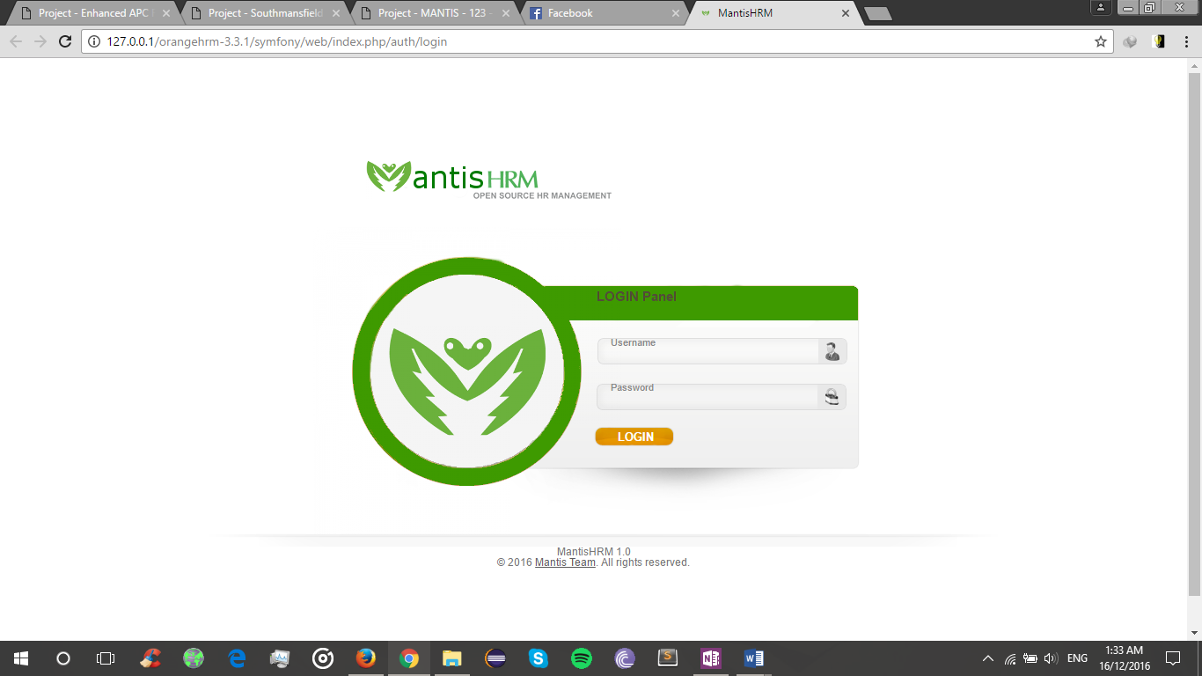

**Admin Dashboard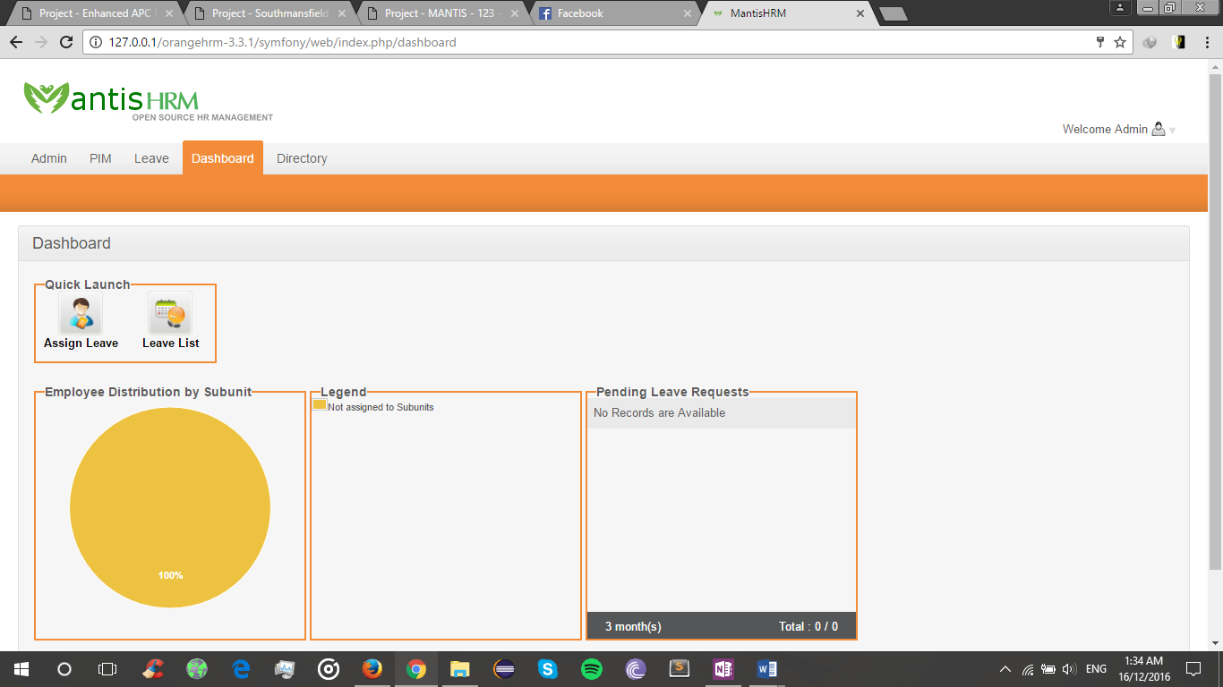 Leave Module for Admin**

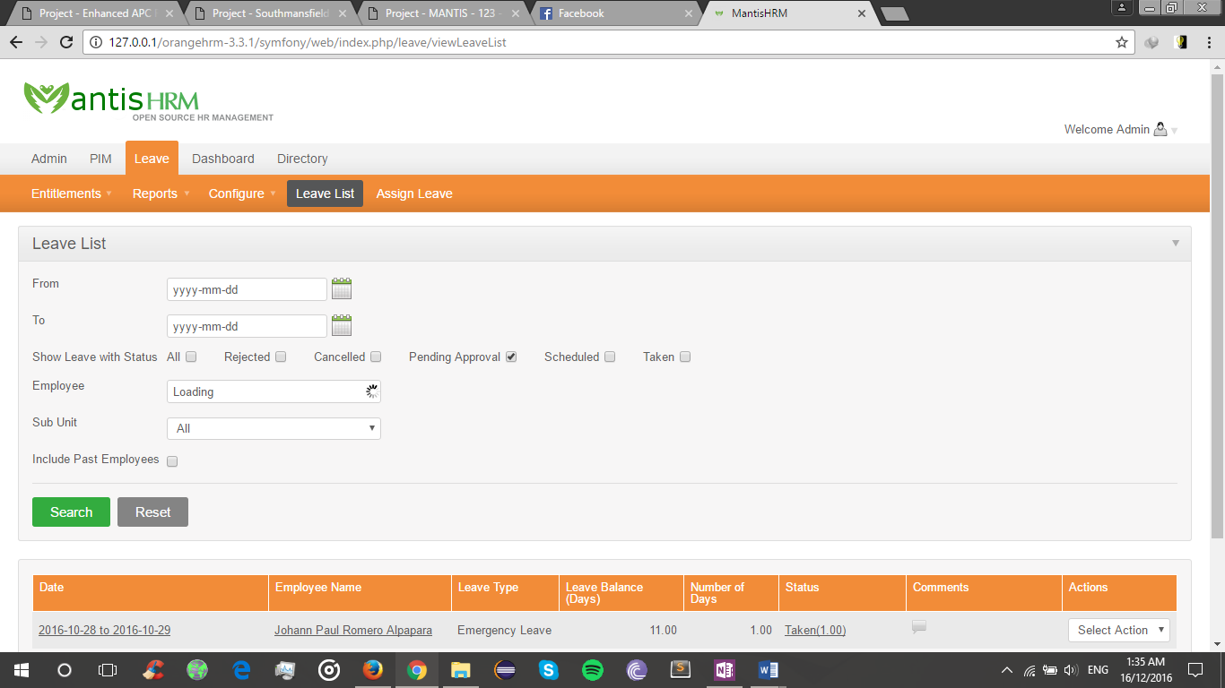

**PIM module for Admin**

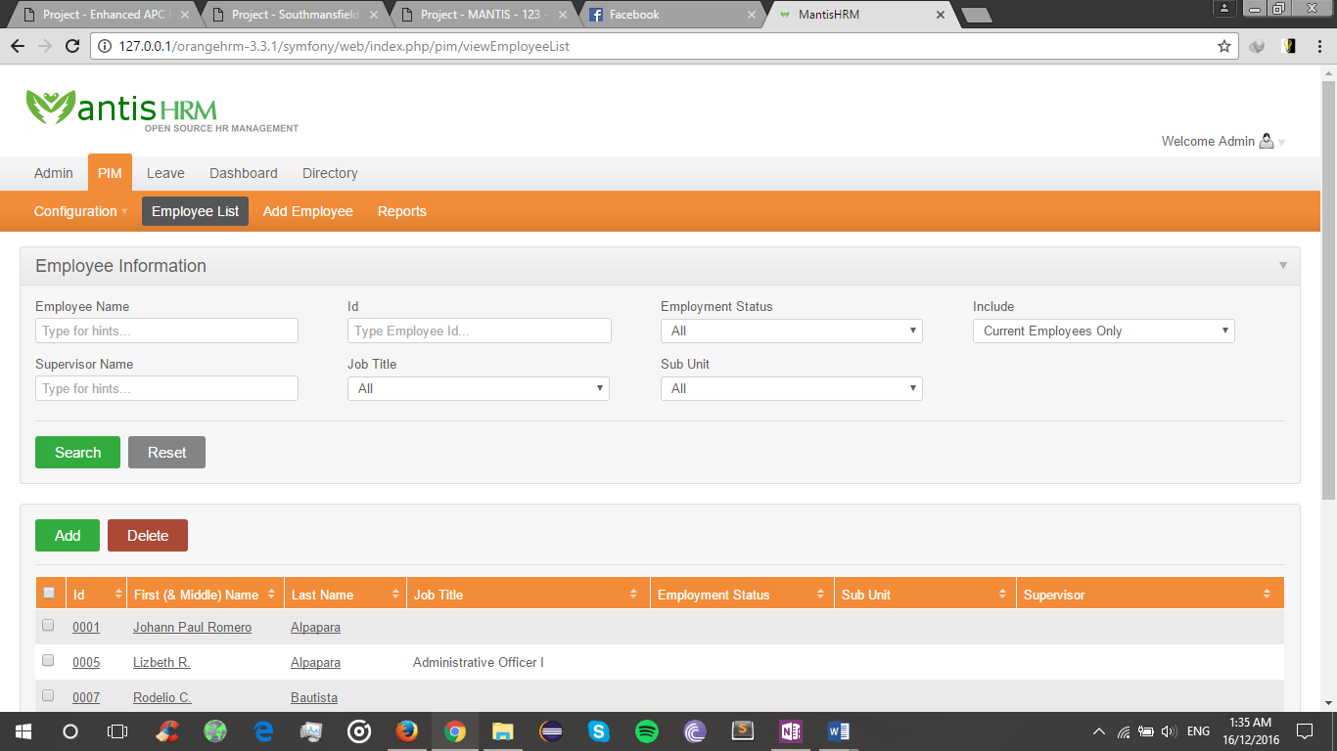

**Leave module for Employee**

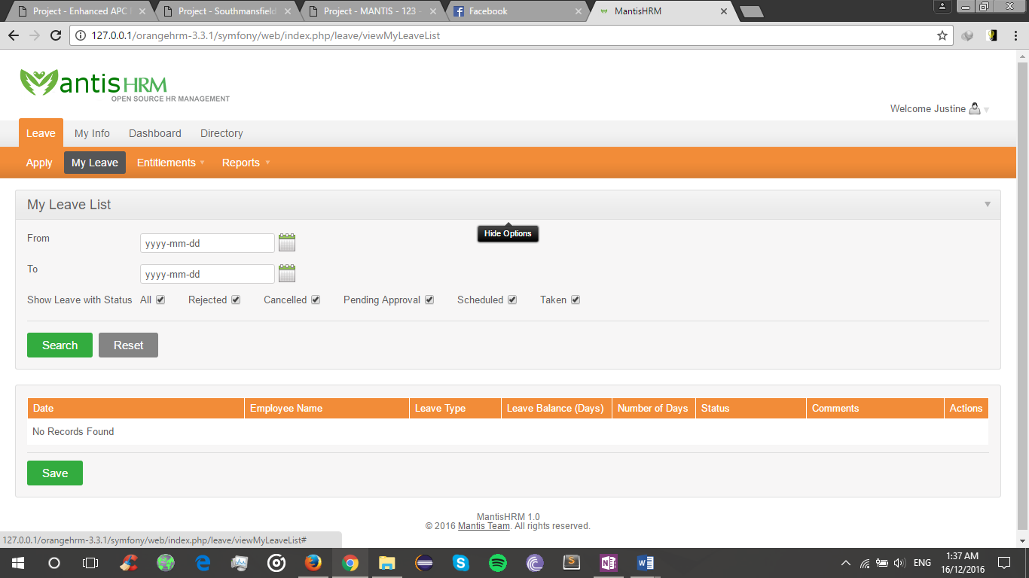

**Myinfo for Employee**

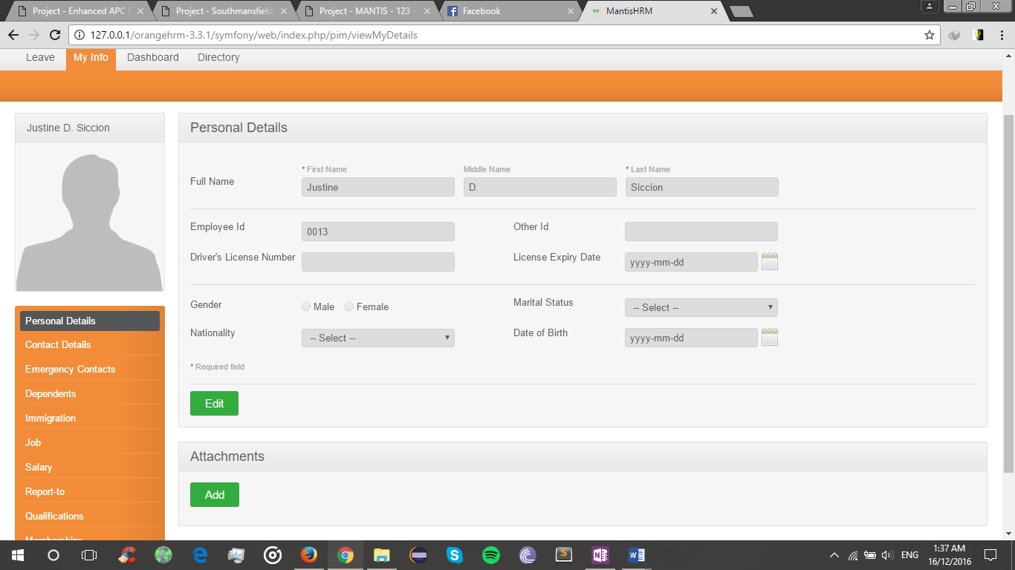

- Pictures showcasing the data gathering, investigation done (e.g. floor plan, layout, building, etc.)

## **UML Diagrams**

## **WBS**

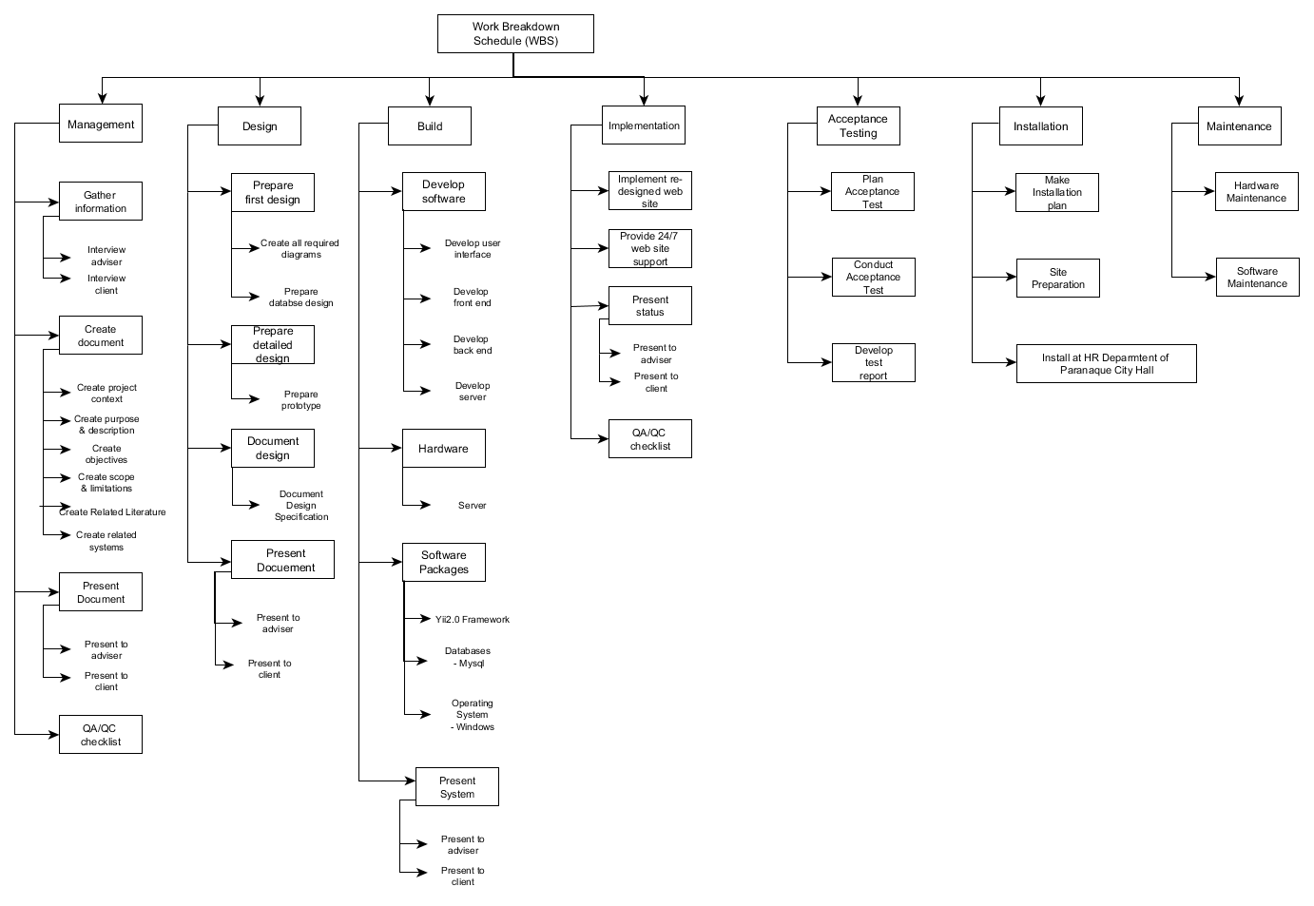

## **Event Table**

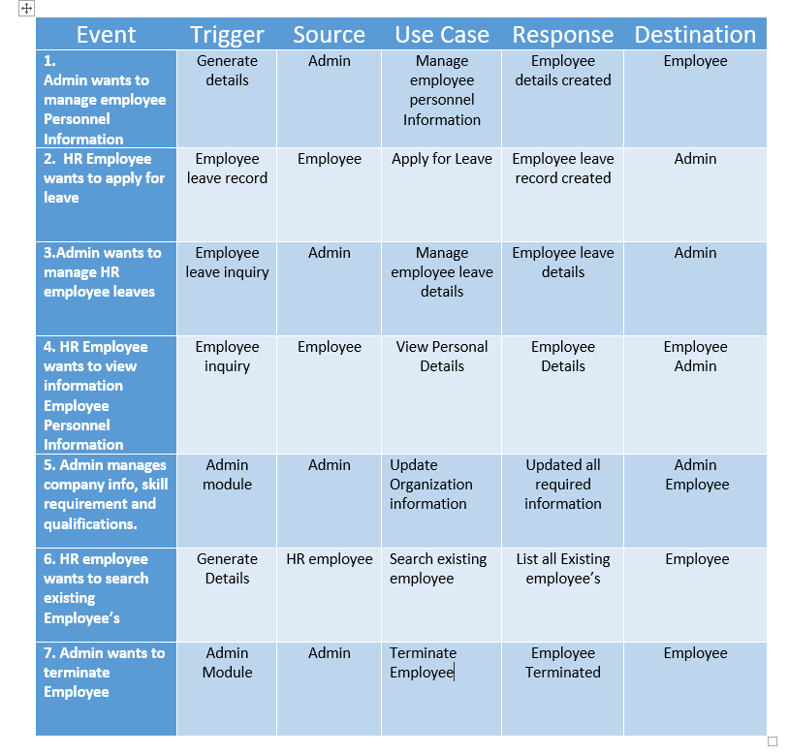

## **Use Case Diagram**

**Use Case Diagram for Leave module**

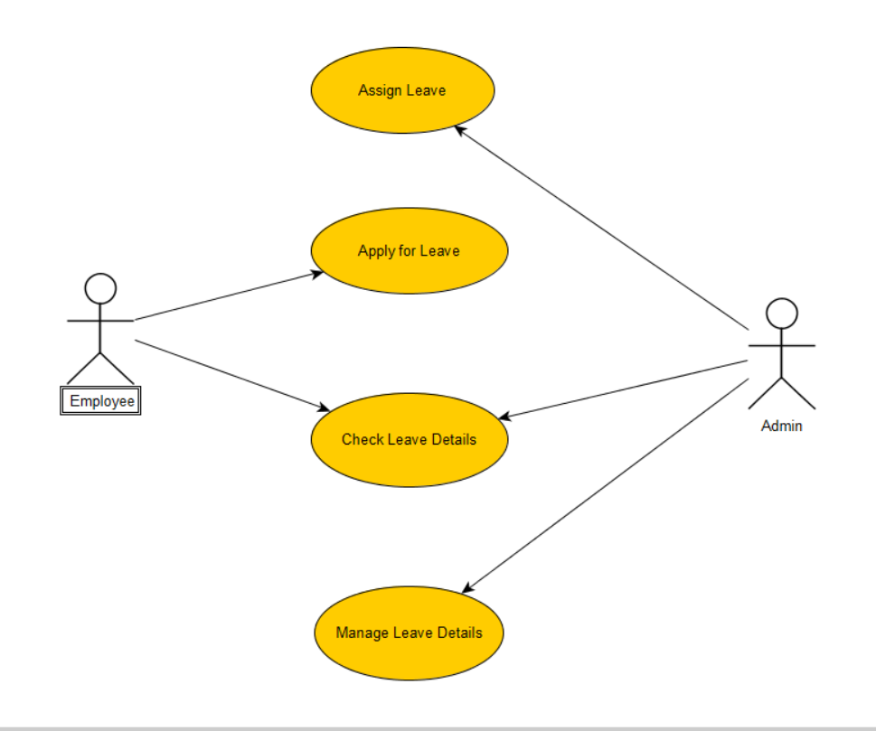

**Use Case Diagram for PIM module**

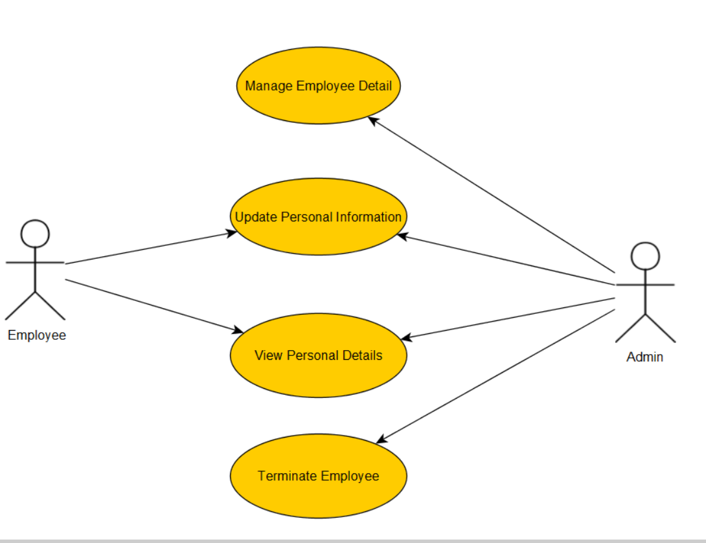

**Use case Diagram for Admin**

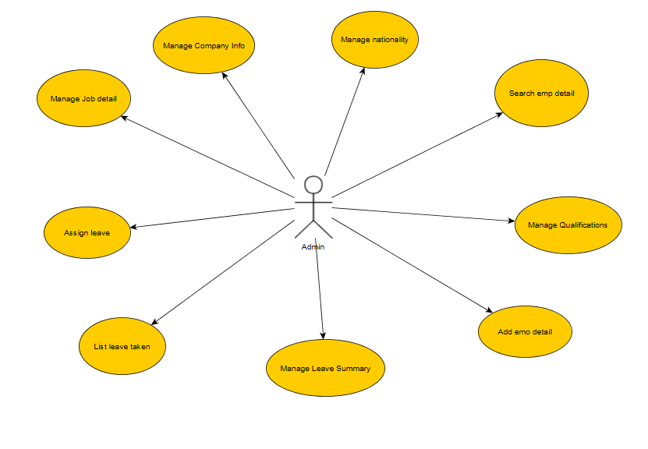

## **Activity Diagram**

**Activity Diagram Employee Leave**

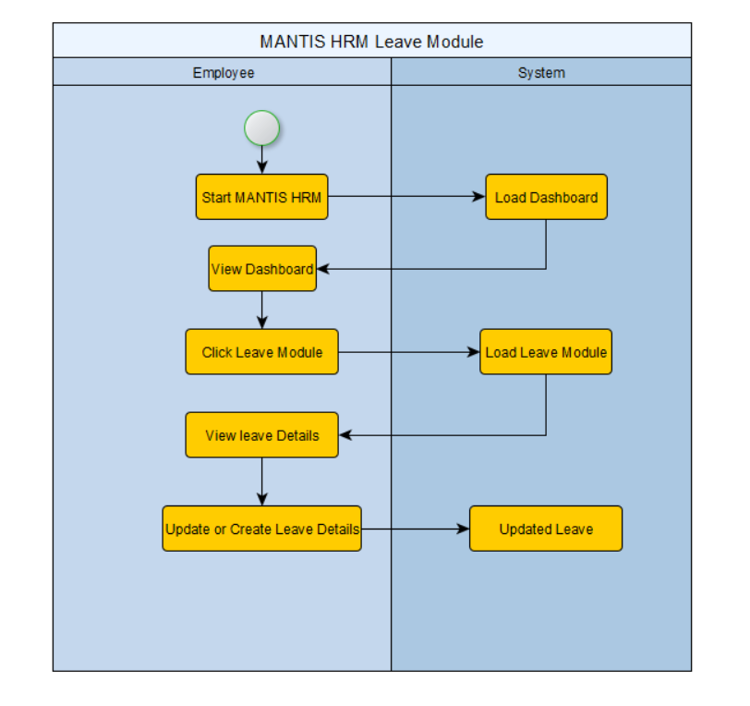

**Activity Diagram Admin Leave Module**

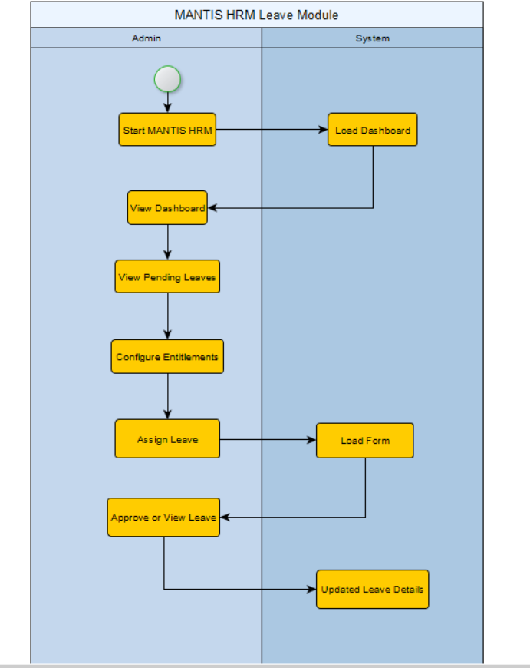

**Activity Diagram Employee My Info**

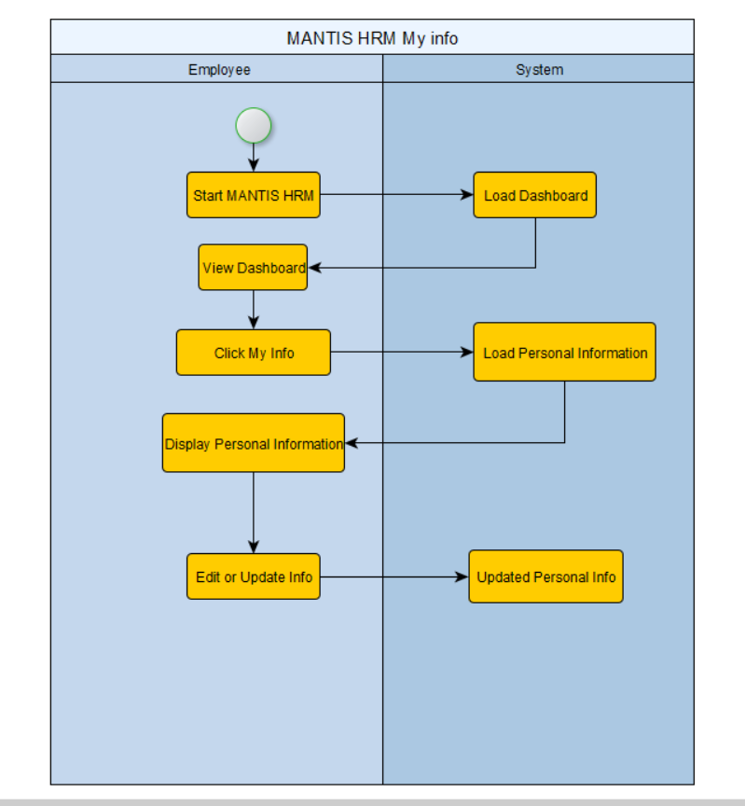

**Activity Diagram Admin PIM module**

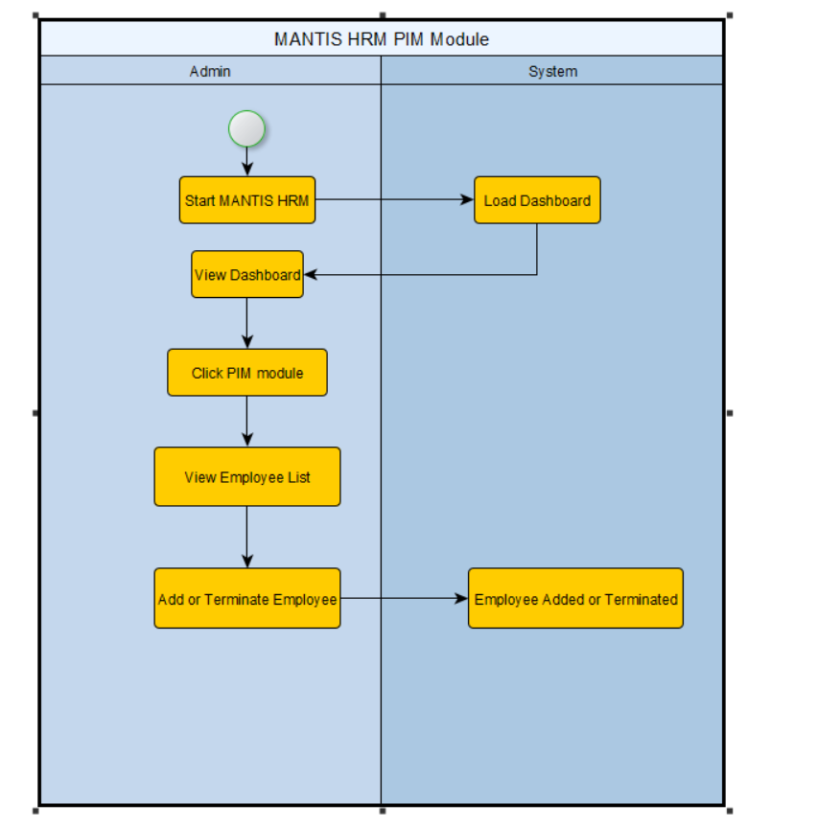

## **Sequence Diagram**

**Admin Sequence Diagram**

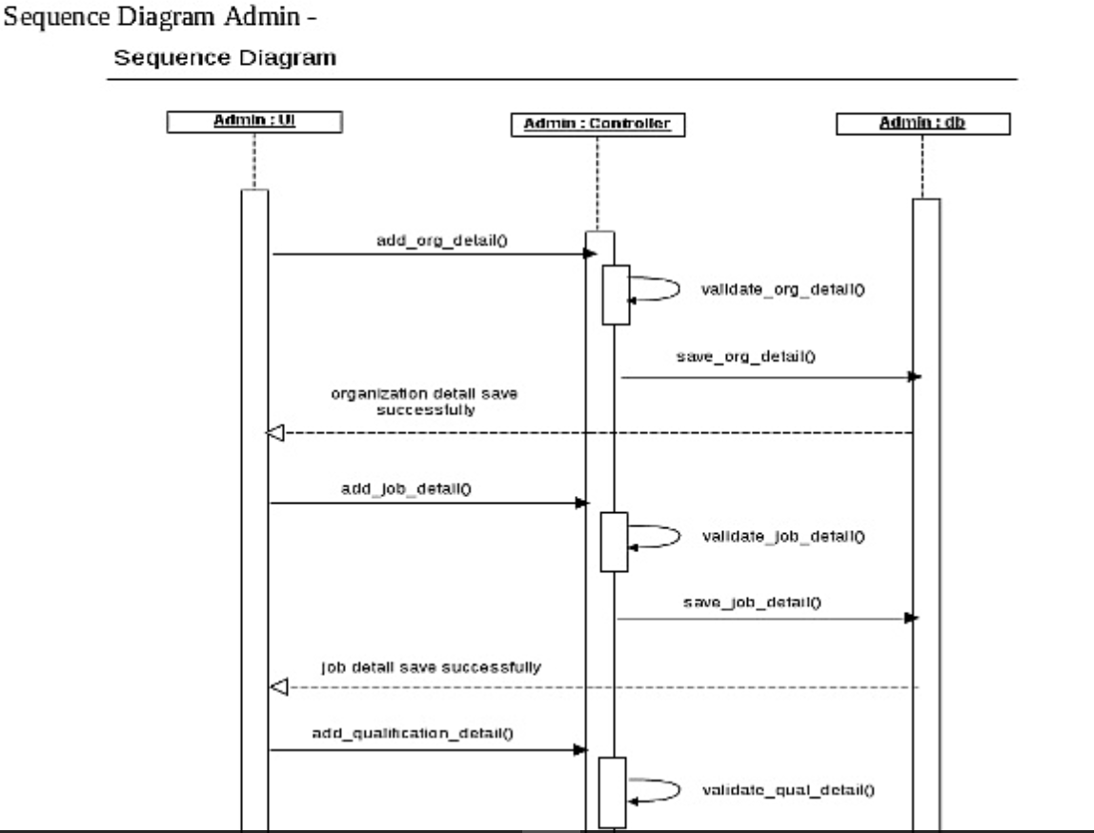

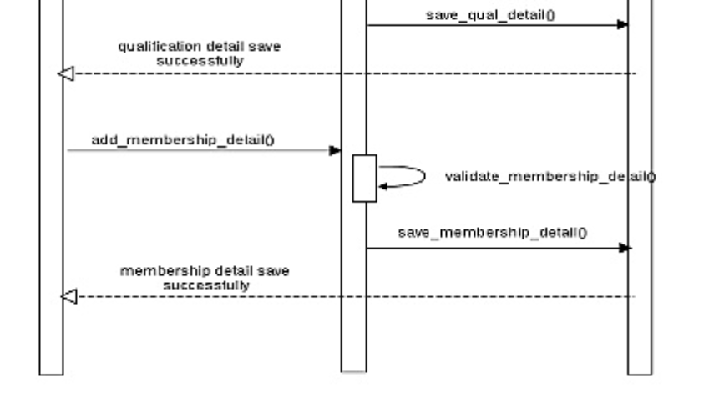

**Sequence Diagram for PIM module**

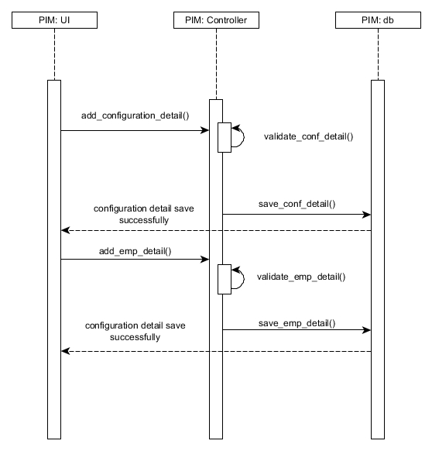

**Sequence Diagram for Leave Module**

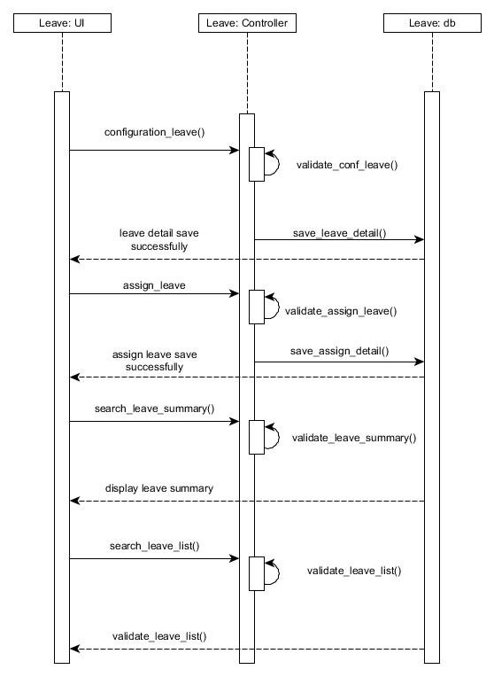

## **Use case full description**

|  |  |  |
| --- | --- | --- |
| Use Case Name: | Update Personal information | |
| Scenario: | Employee or Admin updates Personal Information | |
| Triggering Event: | Generates Employee’s Complete Information | |
| Brief Description: | Admin wants to View Personal details in the PIM module. Then the employee can view or edit the information in the Myinfo tab. | |
| Actors: | Admin, Employee | |
| Related Use Case: | Includes: View employee details. | |
| Stakeholders: | Employee | |
| Preconditions: | Admin should receive employee information via resume or application form | |
| Post conditions: | Employee should exist in the company. | |
| Flow of Activities: | Actor | System |
| 1. Admin receives employees resume and information 2. Creates Employee details 3. HR Employee views Employee personnel details 4. Employee Updates Personal Details | 2.1 Generates employee details  3.1 Updated employee details  4.1 Updated Personal Details |
| Exception Conditions: | If new employee doesn’t exist, then this use case will not add new employee details and will manage existing. | |

Use Case for PIM

|  |  |  |
| --- | --- | --- |
| Use Case Name: | Terminate Employee | |
| Scenario: | Admin will Terminate Employee | |
| Triggering Event: | Terminates Employee from the system | |
| Brief Description: | Admin will terminate specific employee because of resignation or for private reasons | |
| Actors: | Admin, Employee | |
| Related Use Case: | Includes: none | |
| Stakeholders: | Employee | |
| Preconditions: | Employee must be leaving the company for personal reasons | |
| Post conditions: | Employee should exist in the company. | |
| Flow of Activities: | Actor | System |
| 1. Admin searches for Employee’s 2. Admin Terminates specific employee | 1.1 Generates list of Employees  1.1 Employee is Terminated. |
| Exception Conditions: | If employee doesn’t exist, then this use case will not add new employee details and will manage existing. | |

|  |  |  |
| --- | --- | --- |
| Use Case Name: | View Personal Details | |
| Scenario: | Employee or Admin Views Personal Information | |
| Triggering Event: | Generates Employee’s Complete Information | |
| Brief Description: | Admin wants to View Personal details in the PIM module. Then the Employee can view or edit the information in the Myinfo tab. | |
| Actors: | Admin, Employee | |
| Related Use Case: | Includes: Update Personal Information | |
| Stakeholders: | Employee | |
| Preconditions: | Employee Personal Information must be created | |
| Post conditions: | Employee should exist in the company. | |
| Flow of Activities: | Actor | System |
| 1. Admin view specific Employee Personal Information in the PIM module 2. Employee views Employee Personal details in Myinfo tab | 1.1 Generates Personal details  1.1 Generates Personal details |
| Exception Conditions: | If employee doesn’t exist, then this use case will not add new employee details and will manage existing. | |

|  |  |  |
| --- | --- | --- |
| Use Case Name: | Manage Employee Details | |
| Scenario: | Admin Manages Employee Details | |
| Triggering Event: | Generates Employee’s Complete Information | |
| Brief Description: | Admin wants search, delete or add new Employee Personal Information | |
| Actors: | Admin | |
| Related Use Case: | Includes: none | |
| Stakeholders: | Employee | |
| Preconditions: | Must be admin in this process | |
| Post conditions: | None | |
| Flow of Activities: | Actor | System |
| 1. Admin search Employee Personal Information 2. Admin will manage existing Employee details 3. Admin will add new Employee Information | 1.1 Search employee’s   * 1. Deletes Employee Information from database   2. New Employee will be added to the database.   3. New Employee information |
| Exception Conditions: | None | |

|  |  |  |
| --- | --- | --- |
| Use Case Name: | Apply for Leave | |
| Scenario: | Employee applies for leave in the system | |
| Triggering Event: | Update or Create Leave Details | |
| Brief Description: | If there is a pending request form the HR employee for leave the admin will manage or verify leave details. | |
| Actors: | Employee | |
| Related Use Case: | Includes: Manage employee Leave | |
| Stakeholders: | Admin: To verify and manage employee leave details. | |
| Preconditions: | Employee must exist.  Leave types and leave record forms should exist. | |
| Post conditions: | Admin should verify and manage the leave record | |
| Flow of Activities: | Actor | System |
| 1. Employee wants to apply for leave 2. Employee checks leave details 3. Employee inputs new leave record | 2.1 Display record of leaves   * 1. Updated new leave record   4.1 Display updated leave record |
| Exception Conditions: |  | |

Use Case for Leave Module

|  |  |  |
| --- | --- | --- |
| Use Case Name: | Check leave Details | |
| Scenario: | Employee wants to view his/her Leave Details | |
| Triggering Event: | Employee leave inquiry | |
| Brief Description: | or the Admin will check the employee leaves details in the system. | |
| Actors: | Employee | |
| Related Use Case: | None | |
| Stakeholders: | Employee: To View Leave Details | |
| Preconditions: | Employee must exist.  Leave details must be created | |
| Post conditions: | None | |
| Flow of Activities: | Actor | System |
| 1. HR Employee wants to view Leave Details | 1.1 Display record of leaves  2.1 Display updated leave record |
| Exception Conditions: | If leave details is not created, then this use case cannot display leave details. | |

|  |  |  |
| --- | --- | --- |
| Use Case Name: | Assign Leave | |
| Scenario: | Admin assigns leave for Employees | |
| Triggering Event: | Leave details updates | |
| Brief Description: | Admin will assign employees leaves. | |
| Actors: | Admin | |
| Related Use Case: | Includes: Manage Leave Details | |
| Stakeholders: | Employee: Receive updated or new Leave details | |
| Preconditions: | Admin must exist.  Leave information must be created | |
| Post conditions: | None | |
| Flow of Activities: | Actor | System |
| 1. Admin will view Leave Details 2. Admin will create Leave and assign to specific Employees | 1.1 Generates Leave Details   * 1. New Leave Details Created.   2. Updated to the HR employee Account. |
| Exception Conditions: | If specific Employee doesn’t exist Admin cannot assign leave records. | |

|  |  |  |
| --- | --- | --- |
| Use Case Name: | Manage Leave details | |
| Scenario: | Admin Manages Leave details for Employees | |
| Triggering Event: | Configure Leave Entitlements and details | |
| Brief Description: | Admin will manage or update leave configuration | |
| Actors: | Admin | |
| Related Use Case: | Includes: none | |
| Stakeholders: | Employee: Receive updated or new Leave details | |
| Preconditions: | Admin must exist.  Leave information must be created | |
| Post conditions: | None | |
| Flow of Activities: | Actor | System |
| 1. Admin will configure Leave Entitlements 2. Admin will update Leave details and configuration 3. Admin will approve, cancel or reject leaves | 1.1 Update Leave Entitlements  2.1 Updated Leave details and configuration.  3.1 |
| Exception Conditions: | None | |

- One-Page Curriculum Vitae per team member

Johann Paul R. Alpapara  
40 Amalingan St. Greenheights Vill. Sucat Pque. City  
09228928710  
johannpaulalpapara@gmail.com

***Developer***

|  |  |
| --- | --- |
| **Profile** | **Developer** A highly focused software developer with seven years’ experience in a variety of development and engineering positions. Organized, methodical and a keen eye for detail results in solid coding and trustworthy software programs. Understanding client requirements and communicating the progress of projects are core values in achieving long lasting business relationships. |

|  |  |  |
| --- | --- | --- |
| **Education** | Asia Pacific College, Magallanes, Makati City | **BS Information Technology,** 2014-2018 |
|  | |
|  | |

|  |  |  |  |  |
| --- | --- | --- | --- | --- |
| **Key Skills** | **Computer Skills:** | *Symfony Framework*  *Yii2 Framework*  *Ruby on Rails Framework* | *PHP*  *HTML/CSS*  *Java* | *Troubleshooting*  *Linux*  *Windows* |
|  |  |  |  |

|  |  |  |
| --- | --- | --- |
| **Experience** | **Software Developer – Asia Pacific College, Makati** |  |
|  | |
| Leading a small team on a variety of development projects and delivering solutions to meet and exceed clients’ briefs.  **Web Developer – Asia Pacific College, Makati**  **Duties**  Maintaining performance of existing client websites.  Suggesting improvements on design and functionality.  Diagnosing and rectifying performance issues. | |

Justine Mark D. Siccion  
B11 Sunflower St. Ferretville Subd. Anitipolo City  
09267389182  
Justine.siccion@yahoo.com

**JOB OBJECTIVE**

IT internship involving programmingg and/or website management  
  
**SUMMARY**

**>** Hard-working, detail-oriented graduates student in Information Technology with abiliy to articulate complex subject matter.  
**>**Excellent interpersonal skills; willing to help, listen and learn.  
  
**EDUCATION**

BS, Information Technology specialize in Mobile and Internet. expected graduation 2017  
Asia Pacific College  
Coursework:Java Programming,PHP programming,HTML and CSS Programming.  
  
**TECHNICAL SKILLS**

Languages: Java,HTML,CSS  
Techonologies: Eclipse,Microsoft Visual Studio 2013,Notepad++  
Packages: MS Offics,Word,Excel and PPT  
Operating Systems: OS X, Windows 10,Linux  
  
**PROJECTS**

**Personal Website** (Present)  
This is our project which each of us need to have an personal website  
which contents a certain data and images. We only allowed use HTML and CSS  
Code and a little bit of java script on it.  
  
**Mobile App Prototype**   
This project focuses on creating useful applications and desingning it with great GUI(Graphical User Inteface)   
we use Visual Basic software create our protoype.

# **Status Reports**



**Project Status Report**



**Project Name: MANTIS**

**Department:**

**Focus Area: Human Resources Management**

**Product/Process: Human Resource Information System**



**Prepared By:**

|  |  |
| --- | --- |
| **Document Owner(s)** | **Project/Organization Role** |
| Johann Paul Alpapara | Project Manager |
| Justin Mark Siccion | Project Researcher |

**Project Status Report Version Control**

|  |  |  |  |
| --- | --- | --- | --- |
| **Version** | **Date** | **Author** | **Change Description** |
| 1.2 | 07/15/16 | Justine Siccion | Document updated |
| 1.4 | 07/18/16 | Justine Siccion | Diagrams added |
| 1.7 | 07/29/16 | Justine Siccion | Updated documents and diagrams |
| 1.9 | 08/5/16 | Justine Siccion | More Diagrams added but incomplete |
| 2.0 | 08/17/16 | Justine Siccion | Building prototype and revising documents |
| 2.2 | 08/21/16 | Justine Siccion | Configure Prototype and Finalizing diagrams |
| 2.2.1 | 7/21/16 | Justine Siccion  Johann Alpapara | Revising Diagrams and Database and Creating Draft for Project Scope and Vision Document and Statement of Work. |
| 2.2.2 | 16/10/16 | Justine Siccion  Johann Alpapara | Creating Draft for Gantt char and Activity List Documents |

# PROJECT STATUS REPORT PURPOSE

Learned the needs of the current client. HRIS is needed for faster and better management of the Human Resources management office for the City Government of Paranaque.



# PROJECT STATUS REPORT

## Project Status Report Details

MANTIS HRIS

* System Configuration phase
  + Team revising and configuring system database for it is crucial in building the system using Yii2.0
  + Revising Diagrams and Database based on newly acquired information from the client
  + Team studying current existing Open-source HRMS systems.
  + Diagrams and Documentations currently on going before in preparation for presentation of systems for the client.
  + Fast team collaboration for doing documentations determining the success of the project.
  + Creating a Draft for the Project Vision and Scope Documentation to be presented.
  + Creating draft of Statement of Work to be presented.
  + Creating Gantt chart and Activity List documents to be presented.
* Possible Transportation expenses.
* Unavailability of the team or the client creates negative impact for the progress of the project.
* Early scheduling of interview for the client to be ahead of the project planning schedule.

## Project Status Report

|  |  |  |
| --- | --- | --- |
| Project Name: MANTIS HRIS | | |
| Prepared By:  Justine Mark D. Siccion | Date:  08/29/16 | Reporting Period:  08/29/16 to 09/4/16 |
| Project Overall Status:  Currently Studying the existing Open-source HRS that will be configured. Client to be interviewed to ask all needed information. Revising Diagrams and Database based on newly acquired information from the client. Project Vision and Scope Documentation draft still in progress to be presented. Also creating the Gantt chart and Activity List documents. Statement of Work still in progress to be presented also. | | |
| Project Summary:  Revising Diagrams and finalizing database for the system. Project Scope and Vision draft in progress for presentation. And Creating Gantt chart and Activity List documents. Statement of Work still in progress to be presented also. | | |
| **Milestone Deliverables performance reporting over last period**   |  |  |  |  | | --- | --- | --- | --- | | **Milestone Deliverables** | **Due Date** | **% Completed** | **Deliverable Status** | | Milestone 1 | | | | | * Diagrams | 18/1016 | 60% | On Schedule | | * Online Reports (Github, Onenote, Projects Wiki) | 18/1016 | 60% | On Schedule | | * Information Collection (Online Sources and from Client) | 18/1016 | 80% | On Schedule | | * Project Vision and Scope | 18/1016 | 70% | On Schedule | | * Statement of Work | 18/1016 | 70% | On Schedule | | * Gantt Chart | Unknown | 10% | On Schedule | | * Activity List | Unknown | 0% | On Schedule | | Milestone 2 | | | | | * Configuration of System | 17/1016 | 30% | Behind Schedule | | * Online Reports (Github, Onenote, Projects Wiki) | 17/1016 | 60% |  | | | |
| **Milestone Deliverables scheduled for completion over next period**   |  |  |  |  | | --- | --- | --- | --- | | **Milestone Deliverables** | **Due Date** | **% Completed** | **Deliverable Status** | | Milestone 1 | | | | | * Revised Diagrams | 23/10/16 | 70% |  | | * Revised Documents | 23/10/16 | 70% |  | | * Improve prototype | 23/10/16 | 30% |  | | Milestone 2 | | | | | * Collected all Reports | 23/10/16 | 70% |  | | * Interview Client | 23/10/16 | 80% |  | |  |  |  |  | | | |
| **Project impact of milestone success or failure for project remainder**   |  |  | | --- | --- | | Information changes may lead to constant updates of deliverables. | The project schedule would be adjusted according to the delay of progress. | | | |
| **Project** **Budget/Financial Status**   |  |  |  |  | | --- | --- | --- | --- | | **Budget Item** | **Planned Budget** | **Actual Cost** | **Variance/Explanation** | | NA | NA | NA | NA | |  |  |  |  | | | |
| **Project Risk Management Status**   |  |  |  |  |  | | --- | --- | --- | --- | --- | | **Risk and Description** | **Risk Chance** | **Risk Impact** | **Risk Priority** | **Change from Last Review** | | * System Design | High | High | High | Designing a proposed system | | * Updates in documentation | Medium | High | High | Updating few details | | * Prototype | High | High | High | Configuring and coding. | | | |
| **Project Issue Management Status**   |  |  |  |  |  | | --- | --- | --- | --- | --- | | **Issue and Description** | **Project Impact** | **Target Due Date** | **Issue Status** | **Issue Resolution** | | * Limited knowledge in coding using Yii2.0 | High | NA | Closed | Research and practice. | | * Client is hard to interview and does not accommodate us well. Will try to interview again to gather more information | High | 09/10/2016 | Open | Interview them ASAP.  Gather more info from the client. | | | |
| **Project Recommendations**   |  | | --- | | * Will the project be completed on time?   -The project will be behind the schedule   * Will the project deliverables be completed within acceptable quality levels?   -The project deliverables would be check by our project adviser to maintain its quality.   * Are all customer concerns being addressed successfully?   -Yes, all of the client’s concern are addressed properly and successfully | | | |
| **Objectives for Next Project Status Review**   |  | | --- | | For the next review the project documents and diagrams must be improved and organize.  Prototype must now start configuring and adding more working modules. The Scope and Vision Documentation should be almost complete for presentation. | | | |
| **Related Project Information**   |  | | --- | |  | | | |



# PROJECT STATUS REPORT APPROVALS

**Prepared by** Justine Mark D Siccion

Project Researcher

**Approved by** Jose Quesada

Project Advisor

Paranaque City Hall

Client Sponsor





**Project Status Report**



**Project Name: MANTIS**

**Department:**

**Focus Area: Human Resources Management**

**Product/Process: Human Resource Information System**



**Prepared By:**

|  |  |
| --- | --- |
| **Document Owner(s)** | **Project/Organization Role** |
| Johann Paul Alpapara | Project Manager |
| Justin Mark Siccion | Project Researcher |

**Project Status Report Version Control**

|  |  |  |  |
| --- | --- | --- | --- |
| **Version** | **Date** | **Author** | **Change Description** |
| 1.2 | 07/15/16 | Johann Alpapara | Document updated |
| 1.4 | 07/18/16 | Justine Siccion | Diagrams added |
| 1.7 | 07/29/16 | Justine Siccion | Updated documents and diagrams |
| 1.9 | 08/5/16 | Justine Siccion | More Diagrams added but incomplete |
| 2.0 | 08/17/16 | Justine Siccion  Johann Alpapara | Building prototype and revising documents |
| 2.2 | 08/21/16 | Justine Siccion | Configure Prototype and Finalizing diagrams |
| 2.2.1 | 7/21/16 | Justine Siccion  Johann Alpapara | Revising Diagrams and Database and Creating Draft for Project Scope and Vision Document and Statement of Work. |
| 2.2.2 | 16/10/16 | Justine Siccion  Johann Alpapara | Creating Draft for Gantt char and Activity List Documents |

# PROJECT STATUS REPORT PURPOSE

Learned the needs of the current client. HRIS is needed for faster and better management of the Human Resources management office for the City Government of Paranaque.



# PROJECT STATUS REPORT

## Project Status Report Details

MANTIS HRIS

* System Configuration phase
  + Team revising and configuring system database for it is crucial in building the system using Yii2.0
  + Revising Diagrams and Database based on newly acquired information from the client
  + Team studying current existing Open-source HRMS systems.
  + Diagrams and Documentations currently on going before in preparation for presentation of systems for the client.
  + Fast team collaboration for doing documentations determining the success of the project.
  + Creating a Draft for the Project Vision and Scope Documentation to be presented.
  + Creating draft of Statement of Work to be presented.
  + Creating Gantt chart and Activity List documents to be presented.
* Possible Transportation expenses.
* Unavailability of the team or the client creates negative impact for the progress of the project.
* Early scheduling of interview for the client to be ahead of the project planning schedule.

## Project Status Report

|  |  |  |
| --- | --- | --- |
| Project Name: MANTIS HRIS | | |
| Prepared By:  Justine Mark D. Siccion | Date:  18/10/16 | Reporting Period:  18/10/16to 30/10/16 |
| Project Overall Status:  Currently Studying the existing Open-source HRS that will be configured. Client to be interviewed to ask all needed information. Revising Diagrams and Database based on newly acquired information from the client. Project Vision and Scope Documentation draft still in progress to be presented. Also creating the Gantt chart and Activity List documents. Statement of Work still in progress to be presented also. | | |
| Project Summary:  Revising Diagrams and finalizing database for the system. Project Scope and Vision draft in progress for presentation. And Creating Gantt chart and Activity List documents. Statement of Work still in progress to be presented also. | | |
| **Milestone Deliverables performance reporting over last period**   |  |  |  |  | | --- | --- | --- | --- | | **Milestone Deliverables** | **Due Date** | **% Completed** | **Deliverable Status** | | Milestone 1 | | | | | * Diagrams | 18/10/16 | 60% | On Schedule | | * Online Reports (Github, Onenote, Projects Wiki) | 18/10/16 | 60% | On Schedule | | * Information Collection (Online Sources and from Client) | 18/10/16 | 80% | On Schedule | | * Project Vision and Scope | 18/10/16 | 70% | On Schedule | | * Statement of Work | 18/10/16 | 70% | On Schedule | | * Gantt Chart | Unknown | 10% | On Schedule | | * Activity List | Unknown | 0% | On Schedule | | Milestone 2 | | | | | * Configuration of System | 18/10/16 | 30% | Behind Schedule | | * Online Reports (Github, Onenote, Projects Wiki) | 18/10/16 | 60% |  | | | |
| **Milestone Deliverables scheduled for completion over next period**   |  |  |  |  | | --- | --- | --- | --- | | **Milestone Deliverables** | **Due Date** | **% Completed** | **Deliverable Status** | | Milestone 1 | | | | | * Revised Diagrams | 24/10/16 | 70% |  | | * Revised Documents | 24/10/16 | 70% |  | | * Improve prototype | 24/10/16 | 35% |  | | Milestone 2 | | | | | * Collected all Reports | 23/10/16 | 70% |  | | * Interview Client | 23/10/16 | 80% |  | |  |  |  |  | | | |
| **Project impact of milestone success or failure for project remainder**   |  |  | | --- | --- | | Information changes may lead to constant updates of deliverables. | The project schedule would be adjusted according to the delay of progress. | | | |
| **Project** **Budget/Financial Status**   |  |  |  |  | | --- | --- | --- | --- | | **Budget Item** | **Planned Budget** | **Actual Cost** | **Variance/Explanation** | | NA | NA | NA | NA | |  |  |  |  | | | |
| **Project Risk Management Status**   |  |  |  |  |  | | --- | --- | --- | --- | --- | | **Risk and Description** | **Risk Chance** | **Risk Impact** | **Risk Priority** | **Change from Last Review** | | * System Design | High | High | High | Designing a proposed system | | * Updates in documentation | Medium | High | High | Updating few details | | * Prototype | High | High | High | Configuring and coding. | | | |
| **Project Issue Management Status**   |  |  |  |  |  | | --- | --- | --- | --- | --- | | **Issue and Description** | **Project Impact** | **Target Due Date** | **Issue Status** | **Issue Resolution** | | * Limited knowledge in coding using Yii2.0 | High | NA | Closed | Research and practice. | | * Client is hard to interview and does not accommodate us well. Will try to interview again to gather more information | High | 09/10/2016 | Open | Interview them ASAP.  Gather more info from the client. | | | |
| **Project Recommendations**   |  | | --- | | * Will the project be completed on time?   -The project will be behind the schedule   * Will the project deliverables be completed within acceptable quality levels?   -The project deliverables would be check by our project adviser to maintain its quality.   * Are all customer concerns being addressed successfully?   -Yes, all of the client’s concern are addressed properly and successfully | | | |
| **Objectives for Next Project Status Review**   |  | | --- | | For the next review the project documents and diagrams must be improved and organize.  Prototype must now start configuring and adding more working modules. The Scope and Vision Documentation should be almost complete for presentation. | | | |
| **Related Project Information**   |  | | --- | |  | | | |



# PROJECT STATUS REPORT APPROVALS

**Prepared by** Justine Mark D Siccion

Project Researcher

**Approved by** Jose Quesada

Project Advisor

Paranaque City Hall

Client Sponsor





**Project Status Report**



**Project Name: MANTIS**

**Department:**

**Focus Area: Human Resources Management**

**Product/Process: Human Resource Information System**



**Prepared By:**

|  |  |
| --- | --- |
| **Document Owner(s)** | **Project/Organization Role** |
| Johann Paul Alpapara | Project Manager |
| Justin Mark Siccion | Project Researcher |

**Project Status Report Version Control**

|  |  |  |  |
| --- | --- | --- | --- |
| **Version** | **Date** | **Author** | **Change Description** |
| 1.2 | 07/15/16 | Johann Alpapara | Document updated |
| 1.4 | 07/18/16 | Justine Siccion | Diagrams added |
| 1.7 | 07/29/16 | Justine Siccion | Updated documents and diagrams |
| 1.9 | 08/5/16 | Justine Siccion | More Diagrams added but incomplete |
| 2.0 | 08/17/16 | Justine Siccion  Johann Alpapara | Building prototype and revising documents |
| 2.2 | 08/21/16 | Justine Siccion | Configure Prototype and Finalizing diagrams |
| 2.2.1 | 7/21/16 | Justine Siccion  Johann Alpapara | Revising Diagrams and Database and Creating Draft for Project Scope and Vision Document and Statement of Work. |
| 2.2.2 | 16/10/16 | Justine Siccion  Johann Alpapara | Creating Draft for Gantt char and Activity List Documents |
| 2.2.3 | 18/10/16 | Johann Alpapara | Building Leave and Employee Information Modules |

# PROJECT STATUS REPORT PURPOSE

Learned the needs of the current client. HRIS is needed for faster and better management of the Human Resources management office for the City Government of Paranaque.



# PROJECT STATUS REPORT

## Project Status Report Details

MANTIS HRIS

* System Configuration phase
  + Team revising and configuring system database for it is crucial in building the system using Yii2.0
  + Revising Diagrams and Database based on newly acquired information from the client
  + Team studying current existing Open-source HRMS systems.
  + Diagrams and Documentations currently on going before in preparation for presentation of systems for the client.
  + Fast team collaboration for doing documentations determining the success of the project.
  + Creating a Draft for the Project Vision and Scope Documentation to be presented.
  + Creating draft of Statement of Work to be presented.
  + Creating Gantt chart and Activity List documents to be presented.
  + Building Leave and Employee Information Modules
* Possible Transportation expenses.
* Unavailability of the team or the client creates negative impact for the progress of the project.
* Early scheduling of interview for the client to be ahead of the project planning schedule.

## Project Status Report

|  |  |  |
| --- | --- | --- |
| Project Name: MANTIS HRIS | | |
| Prepared By:  Justine Mark D. Siccion | Date:  24/10/16 | Reporting Period:  24/10/16 to 30/10/16 |
| Project Overall Status:  Currently Studying the existing Open-source HRS that will be configured. Client to be interviewed to ask all needed information. Revising Diagrams and Database based on newly acquired information from the client. Project Vision and Scope Documentation draft still in progress to be presented. Also creating the Gantt chart and Activity List documents. Statement of Work still in progress to be presented also. | | |
| Project Summary:  Revising Diagrams and finalizing database for the system. Project Scope and Vision draft in progress for presentation. And Creating Gantt chart and Activity List documents. Statement of Work still in progress to be presented also. | | |
| **Milestone Deliverables performance reporting over last period**   |  |  |  |  | | --- | --- | --- | --- | | **Milestone Deliverables** | **Due Date** | **% Completed** | **Deliverable Status** | | Milestone 1 | | | | | * Diagrams | 24/10/16 | 60% | On Schedule | | * Online Reports (Github, Onenote, Projects Wiki) | 24/10/16 | 60% | On Schedule | | * Information Collection (Online Sources and from Client) | 24/10/16 | 80% | On Schedule | | * Project Vision and Scope | 24/10/16 | 70% | On Schedule | | * Statement of Work | 24/10/16 | 70% | On Schedule | | * Gantt Chart | Unknown | 10% | On Schedule | | * Activity List | Unknown | 0% | On Schedule | | Milestone 2 | | | | | * Configuration of System | 24/10/16 | 30% | Behind Schedule | | * Online Reports (Github, Onenote, Projects Wiki) | 24/10/16 | 60% |  | | | |
| **Milestone Deliverables scheduled for completion over next period**   |  |  |  |  | | --- | --- | --- | --- | | **Milestone Deliverables** | **Due Date** | **% Completed** | **Deliverable Status** | | Milestone 1 | | | | | * Revised Diagrams | 30/10/16 | 70% |  | | * Revised Documents | 30/10/16 | 70% |  | | * Improve prototype | 30/10/16 | 35% |  | | Milestone 2 | | | | | * Collected all Reports | 23/10/16 | 70% |  | | * Interview Client | 23/10/16 | 80% |  | |  |  |  |  | | | |
| **Project impact of milestone success or failure for project remainder**   |  |  | | --- | --- | | Information changes may lead to constant updates of deliverables. | The project schedule would be adjusted according to the delay of progress. | | | |
| **Project** **Budget/Financial Status**   |  |  |  |  | | --- | --- | --- | --- | | **Budget Item** | **Planned Budget** | **Actual Cost** | **Variance/Explanation** | | NA | NA | NA | NA | |  |  |  |  | | | |
| **Project Risk Management Status**   |  |  |  |  |  | | --- | --- | --- | --- | --- | | **Risk and Description** | **Risk Chance** | **Risk Impact** | **Risk Priority** | **Change from Last Review** | | * System Design | High | High | High | Designing a proposed system | | * Updates in documentation | Medium | High | High | Updating few details | | * Prototype | High | High | High | Configuring and coding. | | | |
| **Project Issue Management Status**   |  |  |  |  |  | | --- | --- | --- | --- | --- | | **Issue and Description** | **Project Impact** | **Target Due Date** | **Issue Status** | **Issue Resolution** | | * Limited knowledge in coding using Yii2.0 | High | NA | Closed | Research and practice. | | * Client is hard to interview and does not accommodate us well. Will try to interview again to gather more information | High | 09/10/2016 | Open | Interview them ASAP.  Gather more info from the client. | | | |
| **Project Recommendations**   |  | | --- | | * Will the project be completed on time?   -The project will be behind the schedule   * Will the project deliverables be completed within acceptable quality levels?   -The project deliverables would be check by our project adviser to maintain its quality.   * Are all customer concerns being addressed successfully?   -Yes, all of the client’s concern are addressed properly and successfully | | | |
| **Objectives for Next Project Status Review**   |  | | --- | | For the next review the project documents and diagrams must be improved and organize.  Prototype must now start configuring and adding more working modules. The Scope and Vision Documentation should be almost complete for presentation. | | | |
| **Related Project Information**   |  | | --- | |  | | | |



# PROJECT STATUS REPORT APPROVALS

**Prepared by** Justine Mark D Siccion

Project Researcher

**Approved by** Jose Quesada

Project Advisor

Paranaque City Hall

Client Sponsor





**Project Status Report**



**Project Name: MANTIS**

**Department:**

**Focus Area: Human Resources Management**

**Product/Process: Human Resource Information System**



**Prepared By:**

|  |  |
| --- | --- |
| **Document Owner(s)** | **Project/Organization Role** |
| Johann Paul Alpapara | Project Manager |
| Justin Mark Siccion | Project Researcher |

**Project Status Report Version Control**

|  |  |  |  |
| --- | --- | --- | --- |
| **Version** | **Date** | **Author** | **Change Description** |
| 1.2 | 07/15/16 | Justine Siccion | Document updated |
| 1.4 | 07/18/16 | Justine Siccion | Diagrams added |
| 1.7 | 07/29/16 | Justine Siccion | Updated documents and diagrams |
| 1.9 | 08/5/16 | Justine Siccion | More Diagrams added but incomplete |
| 2.0 | 08/17/16 | Justine Siccion | Building prototype and revising documents |
| 2.2 | 08/21/16 | Justine Siccion | Configure Prototype and Finalizing diagrams |

# PROJECT STATUS REPORT PURPOSE

Learned the needs of the current client. HRIS is needed for faster and better management of the Human Resources management office for the City Government of Paranaque.



# PROJECT STATUS REPORT

## Project Status Report Details

MANTIS HRM

* Diagram Designing and Documentations Phase
  + Team studying current existing Open-source HRMS systems.
  + Diagrams and Documentations currently on going before in preparation for presentation of systems for the client.
  + Fast team collaboration for doing documentations determining the success of the project.
* Possible Transportation expenses.
* Unavailability of the team or the client creates negative impact for the progress of the project.
* Early scheduling of interview for the client to be ahead of the project planning schedule.

## Project Status Report

|  |  |  |
| --- | --- | --- |
| Project Name: MANTIS HRIS | | |
| Prepared By:  Justine Mark D. Siccion | Date:  08/29/16 | Reporting Period:  08/29/16 to 09/4/16 |
| Project Overall Status:  Currently Studying the existing Open-source HRS that will be configured. Client to be interviewed to ask all needed information. Project Documents and Diagrams in Progress and still revising and building a system prototype. | | |
| Project Summary:  Revising Diagrams and finalizing database for the system. | | |
| **Milestone Deliverables performance reporting over last period**   |  |  |  |  | | --- | --- | --- | --- | | **Milestone Deliverables** | **Due Date** | **% Completed** | **Deliverable Status** | | Milestone 1 | | | | | * Diagrams | 09/26/16 | 75% | On Schedule | | * Online Reports (Github, Onenote, Projects Wiki) | 09/26/16 | 60% | On Schedule | | * Information Collection (Online Sources and from Client) | 09/26/16 | 60% | Ahead of Schedule | | Milestone 2 | | | | | * Configuration of System | 09/26/16 | 20% |  | | * Online Reports (Github, Onenote, Projects Wiki) | 09/26/16 | 60% |  | | | |
| **Milestone Deliverables scheduled for completion over next period**   |  |  |  |  | | --- | --- | --- | --- | | **Milestone Deliverables** | **Due Date** | **% Completed** | **Deliverable Status** | | Milestone 1 | | | | | * Revised Diagrams | 010/02/16 | 70% |  | | * Revised Documents | 10/02/16 | 70% |  | | * Improve prototype | 10/02/16 | 30% |  | | Milestone 2 | | | | | * Collected all Reports | 10/02/16 | 60% |  | | * Interview Client | 10/02/16 | 60% |  | |  |  |  |  | | | |
| **Project impact of milestone success or failure for project remainder**   |  |  | | --- | --- | | Information changes may lead to constant updates of deliverables. | The project schedule would be adjusted according to the delay of progress. | | | |
| **Project** **Budget/Financial Status**   |  |  |  |  | | --- | --- | --- | --- | | **Budget Item** | **Planned Budget** | **Actual Cost** | **Variance/Explanation** | | NA | NA | NA | NA | |  |  |  |  | | | |
| **Project Risk Management Status**   |  |  |  |  |  | | --- | --- | --- | --- | --- | | **Risk and Description** | **Risk Chance** | **Risk Impact** | **Risk Priority** | **Change from Last Review** | | * System Design | High | High | High | Designing a proposed system | | * Updates in documentation | Medium | High | High | Updating few details | | * Prototype | High | High | High | Configuring and coding. | | | |
| **Project Issue Management Status**   |  |  |  |  |  | | --- | --- | --- | --- | --- | | **Issue and Description** | **Project Impact** | **Target Due Date** | **Issue Status** | **Issue Resolution** | | * Limited knowledge in coding using Yii2.0 | High | NA | Closed | Research and practice. | | * Client is hard to interview and does not accommodate us well. Will try to interview again to gather more information | High | 10/5/16 | Open | Interview them ASAP.  Gather more info from the client. | | | |
| **Project Recommendations**   |  | | --- | | * Will the project be completed on time?   The project will be behind the schedule   * Will the project deliverables be completed within acceptable quality levels?   The project deliverables would be check by our project adviser to maintain its quality.   * Are all customer concerns being addressed successfully? * Yes, all of the client’s concern are addressed properly and successfully | | | |
| **Objectives for Next Project Status Review**   |  | | --- | | For the next review the project documents and diagrams must be improved and organize.  Prototype must now start configuring and adding more working modules. | | | |
| **Related Project Information**   |  | | --- | |  | | | |



# PROJECT STATUS REPORT APPROVALS

**Prepared by** Justine Mar D Siccion

Project Researcher

**Approved by** Jose Quesada

Project Advisor

Paranaque City Hall

Client Sponsor





**Project Status Report**



**Project Name: MANTIS**

**Department:**

**Focus Area: Human Resources Management**

**Product/Process: Human Resource Information System**



**Prepared By:**

|  |  |
| --- | --- |
| **Document Owner(s)** | **Project/Organization Role** |
| Johann Paul Alpapara | Project Manager |
| Justin Mark Siccion | Project Researcher |

**Project Status Report Version Control**

|  |  |  |  |
| --- | --- | --- | --- |
| **Version** | **Date** | **Author** | **Change Description** |
| 1.2 | 07/15/16 | Justine Siccion | Document updated |
| 1.4 | 07/18/16 | Justine Siccion | Diagrams added |
| 1.7 | 07/29/16 | Justine Siccion | Updated documents and diagrams |
| 1.9 | 08/5/16 | Justine Siccion | More Diagrams added but incomplete |
| 2.0 | 08/17/16 | Justine Siccion | Building prototype and revising documents |
| 2.2 | 08/21/16 | Justine Siccion | Configure Prototype and Finalizing diagrams |

# PROJECT STATUS REPORT PURPOSE

Learned the needs of the current client. HRIS is needed for faster and better management of the Human Resources management office for the City Government of Paranaque.



# PROJECT STATUS REPORT

## Project Status Report Details

MANTIS HRM

* Diagram Designing and Documentations Phase
  + Team studying current existing Open-source HRMS systems.
  + Diagrams and Documentations currently on going before in preparation for presentation of systems for the client.
  + Fast team collaboration for doing documentations determining the success of the project.
* Possible Transportation expenses.
* Unavailability of the team or the client creates negative impact for the progress of the project.
* Early scheduling of interview for the client to be ahead of the project planning schedule.

## Project Status Report

|  |  |  |
| --- | --- | --- |
| Project Name: MANTIS HRIS | | |
| Prepared By:  Justine Mark D. Siccion | Date:  08/29/16 | Reporting Period:  08/29/16 to 09/4/16 |
| Project Overall Status:  Currently Studying the existing Open-source HRS that will be configured. Client to be interviewed to ask all needed information. Project Documents and Diagrams in Progress and still revising and building a system prototype. | | |
| Project Summary:  Revising Diagrams and finalizing database for the system. | | |
| **Milestone Deliverables performance reporting over last period**   |  |  |  |  | | --- | --- | --- | --- | | **Milestone Deliverables** | **Due Date** | **% Completed** | **Deliverable Status** | | Milestone 1 | | | | | * Diagrams | 09/26/16 | 75% | On Schedule | | * Online Reports (Github, Onenote, Projects Wiki) | 09/26/16 | 60% | On Schedule | | * Information Collection (Online Sources and from Client) | 09/26/16 | 60% | Ahead of Schedule | | Milestone 2 | | | | | * Configuration of System | 09/26/16 | 20% |  | | * Online Reports (Github, Onenote, Projects Wiki) | 09/26/16 | 60% |  | | | |
| **Milestone Deliverables scheduled for completion over next period**   |  |  |  |  | | --- | --- | --- | --- | | **Milestone Deliverables** | **Due Date** | **% Completed** | **Deliverable Status** | | Milestone 1 | | | | | * Revised Diagrams | 010/02/16 | 70% |  | | * Revised Documents | 10/02/16 | 70% |  | | * Improve prototype | 10/02/16 | 30% |  | | Milestone 2 | | | | | * Collected all Reports | 10/02/16 | 60% |  | | * Interview Client | 10/02/16 | 60% |  | |  |  |  |  | | | |
| **Project impact of milestone success or failure for project remainder**   |  |  | | --- | --- | | Information changes may lead to constant updates of deliverables. | The project schedule would be adjusted according to the delay of progress. | | | |
| **Project** **Budget/Financial Status**   |  |  |  |  | | --- | --- | --- | --- | | **Budget Item** | **Planned Budget** | **Actual Cost** | **Variance/Explanation** | | NA | NA | NA | NA | |  |  |  |  | | | |
| **Project Risk Management Status**   |  |  |  |  |  | | --- | --- | --- | --- | --- | | **Risk and Description** | **Risk Chance** | **Risk Impact** | **Risk Priority** | **Change from Last Review** | | * System Design | High | High | High | Designing a proposed system | | * Updates in documentation | Medium | High | High | Updating few details | | * Prototype | High | High | High | Configuring and coding. | | | |
| **Project Issue Management Status**   |  |  |  |  |  | | --- | --- | --- | --- | --- | | **Issue and Description** | **Project Impact** | **Target Due Date** | **Issue Status** | **Issue Resolution** | | * Limited knowledge in coding using Yii2.0 | High | NA | Closed | Research and practice. | | * Client is hard to interview and does not accommodate us well. Will try to interview again to gather more information | High | 10/5/16 | Open | Interview them ASAP.  Gather more info from the client. | | | |
| **Project Recommendations**   |  | | --- | | * Will the project be completed on time?   The project will be behind the schedule   * Will the project deliverables be completed within acceptable quality levels?   The project deliverables would be check by our project adviser to maintain its quality.   * Are all customer concerns being addressed successfully? * Yes, all of the client’s concern are addressed properly and successfully | | | |
| **Objectives for Next Project Status Review**   |  | | --- | | For the next review the project documents and diagrams must be improved and organize.  Prototype must now start configuring and adding more working modules. | | | |
| **Related Project Information**   |  | | --- | |  | | | |



# PROJECT STATUS REPORT APPROVALS

**Prepared by** Justine Mar D Siccion

Project Researcher

**Approved by** Jose Quesada

Project Advisor

Paranaque City Hall

Client Sponsor





**Project Status Report**



**Project Name: MANTIS**

**Department:**

**Focus Area: Human Resources Management**

**Product/Process: Human Resource Information System**



**Prepared By:**

|  |  |
| --- | --- |
| **Document Owner(s)** | **Project/Organization Role** |
| Johann Paul Alpapara | Project Manager |
| Justin Mark Siccion | Project Researcher |

**Project Status Report Version Control**

|  |  |  |  |
| --- | --- | --- | --- |
| **Version** | **Date** | **Author** | **Change Description** |
| 1.2 | 07/15/16 | Johann Alpapara | Document updated |
| 1.4 | 07/18/16 | Justine Siccion | Diagrams added |
| 1.7 | 07/29/16 | Justine Siccion | Updated documents and diagrams |
| 1.9 | 08/5/16 | Justine Siccion | More Diagrams added but incomplete |
| 2.0 | 08/17/16 | Justine Siccion  Johann Alpapara | Building prototype and revising documents |
| 2.2 | 08/21/16 | Justine Siccion | Configure Prototype and Finalizing diagrams |
| 2.2.1 | 7/21/16 | Justine Siccion  Johann Alpapara | Revising Diagrams and Database and Creating Draft for Project Scope and Vision Document and Statement of Work. |
| 2.2.2 | 16/10/16 | Justine Siccion  Johann Alpapara | Creating Draft for Gantt char and Activity List Documents |
| 2.2.3 | 18/10/16 | Johann Alpapara | Building Leave and Employee Information Modules |
| 2.2.4 | 2/11/16 | Johann Alpapara | Designing the look and feel of the system |
| 2.2.5 | 22/11/16 | Justine Siccion | Creating SRS and Quality Management Plan |

# PROJECT STATUS REPORT PURPOSE

Learned the needs of the current client. HRIS is needed for faster and better management of the Human Resources management office for the City Government of Paranaque.



# PROJECT STATUS REPORT

## Project Status Report Details

MANTIS HRIS

* System Configuration phase
  + Team revising and configuring system database for it is crucial in building the system using PHP framework.
  + Revising Diagrams and Database based on newly acquired information from the client
  + Team studying current existing Open-source HRMS systems.
  + Diagrams and Documentations currently on going before in preparation for presentation of systems for the client.
  + Fast team collaboration for doing documentations determining the success of the project.
  + Creating a Draft for the Project Vision and Scope Documentation to be presented.
  + Creating draft of Statement of Work to be presented.
  + Creating Gantt chart and Activity List documents to be presented.
  + Building Leave and Employee Information Modules
  + Designing the system.
  + Creating SRS and Quality Mangement Plan
* Possible Transportation expenses.
* Unavailability of the team or the client creates negative impact for the progress of the project.
* Early scheduling of interview for the client to be ahead of the project planning schedule.

## Project Status Report

|  |  |  |
| --- | --- | --- |
| Project Name: MANTIS HRIS | | |
| Prepared By:  Justine Mark D. Siccion | Date:  7/11/16 | Reporting Period:  7/11/16 to 27/12/16 |
| Project Overall Status:  Currently Studying the existing Open-source HRS that will be configured. Client to be interviewed to ask all needed information. Revising Diagrams and Database based on newly acquired information from the client. Project Vision and Scope Documentation draft still in progress to be presented. Also creating the Gantt chart and Activity List documents. Statement of Work still in progress to be presented also. | | |
| Project Summary:  Revising Diagrams and finalizing database for the system. Project Scope and Vision draft in progress for presentation. And Creating Gantt chart and Activity List documents. Statement of Work still in progress to be presented also. | | |
| **Milestone Deliverables performance reporting over last period**   |  |  |  |  | | --- | --- | --- | --- | | **Milestone Deliverables** | **Due Date** | **% Completed** | **Deliverable Status** | | Milestone 1 | | | | | * Diagrams | 22/11/16 | 75% | On Schedule | | * Online Reports (Github, Onenote, Projects Wiki) | 22/11/16 | 80% | On Schedule | | * Information Collection (Online Sources and from Client) | 22/11/16 | 88% | On Schedule | | * Project Vision and Scope | 22/11/16 | 85% | On Schedule | | * Statement of Work | 22/11/16 | 85% | On Schedule | | * Gantt Chart | 22/11/16 | 30% | On Schedule | | * Activity List | 22/11/16 | 50% | On Schedule | | * SRS | 22/11/16 | 40% | On Schedule | | * Quality Management Plan | 22/11/16 | 50% | On Schedule | | Milestone 2 | | | | | * Configuration of System | 7/11/16 | 70% | Behind Schedule | | * Online Reports (Github, Onenote, Projects Wiki) | 7/11/16 | 60% |  | | | |
| **Milestone Deliverables scheduled for completion over next period**   |  |  |  |  | | --- | --- | --- | --- | | **Milestone Deliverables** | **Due Date** | **% Completed** | **Deliverable Status** | | Milestone 1 | | | | | * Revised Diagrams | 13/11/16 | 70% |  | | * Revised Documents | 13/11/16 | 70% |  | | * Improve prototype | 13/11/16 | 50% |  | | Milestone 2 | | | | | * Collected all Reports | 13/11/16 | 70% |  | | * Interview Client for new updates about the current system. | 13/11/16 | 10% |  | |  |  |  |  | | | |
| **Project impact of milestone success or failure for project remainder**   |  |  | | --- | --- | | Information changes may lead to constant updates of deliverables. | The project schedule would be adjusted according to the delay of progress. | | | |
| **Project** **Budget/Financial Status**   |  |  |  |  | | --- | --- | --- | --- | | **Budget Item** | **Planned Budget** | **Actual Cost** | **Variance/Explanation** | | NA | NA | NA | NA | |  |  |  |  | | | |
| **Project Risk Management Status**   |  |  |  |  |  | | --- | --- | --- | --- | --- | | **Risk and Description** | **Risk Chance** | **Risk Impact** | **Risk Priority** | **Change from Last Review** | | * System Design | High | High | High | Designing a proposed system | | * Updates in documentation | Medium | High | High | Updating few details | | * System | High | High | High | Configuring and coding. | | | |
| **Project Issue Management Status**   |  |  |  |  |  | | --- | --- | --- | --- | --- | | **Issue and Description** | **Project Impact** | **Target Due Date** | **Issue Status** | **Issue Resolution** | | * Limited knowledge in coding in PHP | High | NA | Closed | Research and practice. | | * Client is hard to interview again for consulting about the current system being develop | High | NA | Closed | Interview them ASAP.  Gather more info from the client. | | | |
| **Project Recommendations**   |  | | --- | | * Will the project be completed on time?   -The project will be behind the schedule   * Will the project deliverables be completed within acceptable quality levels?   -The project deliverables would be check by our project adviser to maintain its quality.   * Are all customer concerns being addressed successfully?   -Yes, all of the client’s concern are addressed properly and successfully | | | |
| **Objectives for Next Project Status Review**   |  | | --- | | For the next review the project documents and diagrams must be improved and organize.  Prototype must now start configuring and adding more working modules. The Scope and Vision Documentation should be almost complete for presentation. | | | |
| **Related Project Information**   |  | | --- | |  | | | |



# PROJECT STATUS REPORT APPROVALS

**Prepared by** Justine Mark D Siccion

Project Researcher

**Approved by** Jose Quesada

Project Advisor

Paranaque City Hall

Client Sponsor





**Project Status Report**



**Project Name: MANTIS**

**Department:**

**Focus Area: Human Resources Management**

**Product/Process: Human Resource Information System**



**Prepared By:**

|  |  |
| --- | --- |
| **Document Owner(s)** | **Project/Organization Role** |
| Johann Paul Alpapara | Project Manager |
| Justin Mark Siccion | Project Researcher |

**Project Status Report Version Control**

|  |  |  |  |
| --- | --- | --- | --- |
| **Version** | **Date** | **Author** | **Change Description** |
| 1.2 | 07/15/16 | Johann Alpapara | Document updated |
| 1.4 | 07/18/16 | Justine Siccion | Diagrams added |
| 1.7 | 07/29/16 | Justine Siccion | Updated documents and diagrams |
| 1.9 | 08/5/16 | Justine Siccion | More Diagrams added but incomplete |
| 2.0 | 08/17/16 | Justine Siccion  Johann Alpapara | Building prototype and revising documents |
| 2.2 | 08/21/16 | Justine Siccion | Configure Prototype and Finalizing diagrams |
| 2.2.1 | 7/21/16 | Justine Siccion  Johann Alpapara | Revising Diagrams and Database and Creating Draft for Project Scope and Vision Document and Statement of Work. |
| 2.2.2 | 16/10/16 | Justine Siccion  Johann Alpapara | Creating Draft for Gantt char and Activity List Documents |
| 2.2.3 | 18/10/16 | Johann Alpapara | Building Leave and Employee Information Modules |
| 2.2.4 | 2/11/16 | Johann Alpapara | Designing the look and feel of the system |
| 2.2.5 | 22/11/16 | Justine Siccion | Creating SRS and Quality Management Plan |

# PROJECT STATUS REPORT PURPOSE

Learned the needs of the current client. HRIS is needed for faster and better management of the Human Resources management office for the City Government of Paranaque.



# PROJECT STATUS REPORT

## Project Status Report Details

MANTIS HRIS

* System Configuration phase
  + Team revising and configuring system database for it is crucial in building the system using PHP framework.
  + Revising Diagrams and Database based on newly acquired information from the client
  + Team studying current existing Open-source HRMS systems.
  + Diagrams and Documentations currently on going before in preparation for presentation of systems for the client.
  + Fast team collaboration for doing documentations determining the success of the project.
  + Creating a Draft for the Project Vision and Scope Documentation to be presented.
  + Creating draft of Statement of Work to be presented.
  + Creating Gantt chart and Activity List documents to be presented.
  + Building Leave and Employee Information Modules
  + Designing the system.
  + Creating SRS and Quality Mangement Plan
* Possible Transportation expenses.
* Unavailability of the team or the client creates negative impact for the progress of the project.
* Early scheduling of interview for the client to be ahead of the project planning schedule.

## Project Status Report

|  |  |  |
| --- | --- | --- |
| Project Name: MANTIS HRIS | | |
| Prepared By:  Justine Mark D. Siccion | Date:  27/11/16 | Reporting Period:  27/11/16 to 4/12/16 |
| Project Overall Status:  Currently Studying the existing Open-source HRS that will be configured. Client to be interviewed to ask all needed information. Revising Diagrams and Database based on newly acquired information from the client. Project Vision and Scope Documentation draft still in progress to be presented. Also creating the Gantt chart and Activity List documents. Statement of Work still in progress to be presented also. | | |
| Project Summary:  Revising Diagrams and finalizing database for the system. Project Scope and Vision draft in progress for presentation. And Creating Gantt chart and Activity List documents. Statement of Work still in progress to be presented also. | | |
| **Milestone Deliverables performance reporting over last period**   |  |  |  |  | | --- | --- | --- | --- | | **Milestone Deliverables** | **Due Date** | **% Completed** | **Deliverable Status** | | Milestone 1 | | | | | * Diagrams | 22/11/16 | 75% | On Schedule | | * Online Reports (Github, Onenote, Projects Wiki) | 22/11/16 | 80% | On Schedule | | * Information Collection (Online Sources and from Client) | 22/11/16 | 88% | On Schedule | | * Project Vision and Scope | 22/11/16 | 85% | On Schedule | | * Statement of Work | 22/11/16 | 85% | On Schedule | | * Gantt Chart | 22/11/16 | 30% | On Schedule | | * Activity List | 22/11/16 | 50% | On Schedule | | * SRS | 22/11/16 | 40% | On Schedule | | * Quality Management Plan | 22/11/16 | 50% | On Schedule | | Milestone 2 | | | | | * Configuration of System | 7/11/16 | 70% | Behind Schedule | | * Online Reports (Github, Onenote, Projects Wiki) | 7/11/16 | 60% |  | | | |
| **Milestone Deliverables scheduled for completion over next period**   |  |  |  |  | | --- | --- | --- | --- | | **Milestone Deliverables** | **Due Date** | **% Completed** | **Deliverable Status** | | Milestone 1 | | | | | * Revised Diagrams | 13/11/16 | 70% |  | | * Revised Documents | 13/11/16 | 70% |  | | * Improve prototype | 13/11/16 | 50% |  | | Milestone 2 | | | | | * Collected all Reports | 13/11/16 | 70% |  | | * Interview Client for new updates about the current system. | 13/11/16 | 10% |  | |  |  |  |  | | | |
| **Project impact of milestone success or failure for project remainder**   |  |  | | --- | --- | | Information changes may lead to constant updates of deliverables. | The project schedule would be adjusted according to the delay of progress. | | | |
| **Project** **Budget/Financial Status**   |  |  |  |  | | --- | --- | --- | --- | | **Budget Item** | **Planned Budget** | **Actual Cost** | **Variance/Explanation** | | NA | NA | NA | NA | |  |  |  |  | | | |
| **Project Risk Management Status**   |  |  |  |  |  | | --- | --- | --- | --- | --- | | **Risk and Description** | **Risk Chance** | **Risk Impact** | **Risk Priority** | **Change from Last Review** | | * System Design | High | High | High | Designing a proposed system | | * Updates in documentation | Medium | High | High | Updating few details | | * System | High | High | High | Configuring and coding. | | | |
| **Project Issue Management Status**   |  |  |  |  |  | | --- | --- | --- | --- | --- | | **Issue and Description** | **Project Impact** | **Target Due Date** | **Issue Status** | **Issue Resolution** | | * Limited knowledge in coding in PHP | High | NA | Closed | Research and practice. | | * Client is hard to interview again for consulting about the current system being develop | High | NA | Closed | Interview them ASAP.  Gather more info from the client. | | | |
| **Project Recommendations**   |  | | --- | | * Will the project be completed on time?   -The project will be behind the schedule   * Will the project deliverables be completed within acceptable quality levels?   -The project deliverables would be check by our project adviser to maintain its quality.   * Are all customer concerns being addressed successfully?   -Yes, all of the client’s concern are addressed properly and successfully | | | |
| **Objectives for Next Project Status Review**   |  | | --- | | For the next review the project documents and diagrams must be improved and organize.  Prototype must now start configuring and adding more working modules. The Scope and Vision Documentation should be almost complete for presentation. | | | |
| **Related Project Information**   |  | | --- | |  | | | |



# PROJECT STATUS REPORT APPROVALS

**Prepared by** Justine Mark D Siccion

Project Researcher

**Approved by** Jose Quesada

Project Advisor

Paranaque City Hall

Client Sponsor





**Project Status Report**



**Project Name: MANTIS**

**Department:**

**Focus Area: Human Resources Management**

**Product/Process: Human Resource Information System**



**Prepared By:**

|  |  |
| --- | --- |
| **Document Owner(s)** | **Project/Organization Role** |
| Johann Paul Alpapara | Project Manager |
| Justin Mark Siccion | Project Researcher |

**Project Status Report Version Control**

|  |  |  |  |
| --- | --- | --- | --- |
| **Version** | **Date** | **Author** | **Change Description** |
| 1.2 | 07/15/16 | Johann Alpapara | Document updated |
| 1.4 | 07/18/16 | Justine Siccion | Diagrams added |
| 1.7 | 07/29/16 | Justine Siccion | Updated documents and diagrams |
| 1.9 | 08/5/16 | Justine Siccion | More Diagrams added but incomplete |
| 2.0 | 08/17/16 | Justine Siccion  Johann Alpapara | Building prototype and revising documents |
| 2.2 | 08/21/16 | Justine Siccion | Configure Prototype and Finalizing diagrams |
| 2.2.1 | 7/21/16 | Justine Siccion  Johann Alpapara | Revising Diagrams and Database and Creating Draft for Project Scope and Vision Document and Statement of Work. |
| 2.2.2 | 16/10/16 | Justine Siccion  Johann Alpapara | Creating Draft for Gantt char and Activity List Documents |
| 2.2.3 | 18/10/16 | Johann Alpapara | Building Leave and Employee Information Modules |
| 2.2.4 | 2/11/16 | Johann Alpapara | Designing the look and feel of the system |
| 2.2.5 | 22/11/16 | Justine Siccion | Creating SRS and Quality Management Plan |
| 2.2.6 | 04/12/2016 | Justine Siccion Johann Alpapara | Finalizing required docuements |

# PROJECT STATUS REPORT PURPOSE

Learned the needs of the current client. HRIS is needed for faster and better management of the Human Resources management office for the City Government of Paranaque.



# PROJECT STATUS REPORT

## Project Status Report Details

MANTIS HRIS

* System Configuration phase
  + Team revising and configuring system database for it is crucial in building the system using PHP framework.
  + Revising Diagrams and Database based on newly acquired information from the client
  + Team studying current existing Open-source HRMS systems.
  + Diagrams and Documentations currently on going before in preparation for presentation of systems for the client.
  + Fast team collaboration for doing documentations determining the success of the project.
  + Creating a Draft for the Project Vision and Scope Documentation to be presented.
  + Creating draft of Statement of Work to be presented.
  + Creating Gantt chart and Activity List documents to be presented.
  + Building Leave and Employee Information Modules
  + Designing the system.
  + Creating SRS and Quality Mangement Plan
  + Finalizing all required documents
* Possible Transportation expenses.
* Unavailability of the team or the client creates negative impact for the progress of the project.
* Early scheduling of interview for the client to be ahead of the project planning schedule.

## Project Status Report

|  |  |  |
| --- | --- | --- |
| Project Name: MANTIS HRIS | | |
| Prepared By:  Justine Mark D. Siccion | Date:  4/12/16 | Reporting Period:  5/12/16 to 11/12/16 |
| Project Overall Status:  Currently Studying the existing Open-source HRS that will be configured. Client to be interviewed to ask all needed information. Finalizing required documents before finishing the system’s design and module. | | |
| Project Summary:  Finalizing all required documents for the system. | | |
| **Milestone Deliverables performance reporting over last period**   |  |  |  |  | | --- | --- | --- | --- | | **Milestone Deliverables** | **Due Date** | **% Completed** | **Deliverable Status** | | Milestone 1 | | | | | * Diagrams | 1/12/2016 | 80% | On Schedule | | * Online Reports (Github, Onenote, Projects Wiki) | 1/12/2016 | 80% | On Schedule | | * Information Collection (Online Sources and from Client) | 1/12/2016 | 100% | On Schedule | | * Project Vision and Scope | 1/12/2016 | 100% | On Schedule | | * Statement of Work | 1/12/2016 | 90% | On Schedule | | * Gantt Chart | 1/12/2016 | 60% | On Schedule | | * Activity List | 1/12/2016 | 70% | On Schedule | | * SRS | 1/12/2016 | 60% | On Schedule | | * Quality Management Plan | 1/12/2016 | 70% | On Schedule | | Milestone 2 | | | | | * Configuration of System | 1/12/2016 | 87% | Behind Schedule | | | |
| **Milestone Deliverables scheduled for completion over next period**   |  |  |  |  | | --- | --- | --- | --- | | **Milestone Deliverables** | **Due Date** | **% Completed** | **Deliverable Status** | | Milestone 1 | | | | | * Revised Diagrams | 11/12/16 | 100% |  | | * Required Documents | 11/12/16 | 100% |  | | * Improve prototype | 11/12/16 | 95% |  | | Milestone 2 | | | | | * Collected all Reports | 11/12/16 | 100% |  | |  |  |  |  | | | |
| **Project impact of milestone success or failure for project remainder**   |  |  | | --- | --- | | Information changes may lead to constant updates of deliverables. | The project schedule would be adjusted according to the delay of progress. | | | |
| **Project** **Budget/Financial Status**   |  |  |  |  | | --- | --- | --- | --- | | **Budget Item** | **Planned Budget** | **Actual Cost** | **Variance/Explanation** | | NA | NA | NA | NA | |  |  |  |  | | | |
| **Project Risk Management Status**   |  |  |  |  |  | | --- | --- | --- | --- | --- | | **Risk and Description** | **Risk Chance** | **Risk Impact** | **Risk Priority** | **Change from Last Review** | | * System Design | High | High | High | Designing a proposed system | | * Updates in documentation | Medium | High | High | Updating few details | | * System | High | High | High | Configuring and coding. | | | |
| **Project Issue Management Status**   |  |  |  |  |  | | --- | --- | --- | --- | --- | | **Issue and Description** | **Project Impact** | **Target Due Date** | **Issue Status** | **Issue Resolution** | | * Limited knowledge in coding in PHP | High | NA | Closed | Research and practice. | | * Client is hard to interview again for consulting about the current system being develop | High | NA | Closed | Interview them ASAP.  Gather more info from the client. | | | |
| **Project Recommendations**   |  | | --- | | * Will the project be completed on time?   -The project will be behind the schedule   * Will the project deliverables be completed within acceptable quality levels?   -The project deliverables would be check by our project adviser to maintain its quality.   * Are all customer concerns being addressed successfully?   -Yes, all of the client’s concern are addressed properly and successfully | | | |
| **Objectives for Next Project Status Review**   |  | | --- | | For the next review the project documents and diagrams must be improved and organize.  Prototype must now start configuring and adding more working modules. The Scope and Vision Documentation should be almost complete for presentation. | | | |
| **Related Project Information**   |  | | --- | |  | | | |



# PROJECT STATUS REPORT APPROVALS

**Prepared by** Justine Mark D Siccion

Project Researcher

**Approved by** Jose Quesada

Project Advisor

Paranaque City Hall

Client Sponsor



# **Vision and Scope Document**

Vision and Scope Document

for

MANTIS HRM

Version 1.2 approved

Prepared by: Justine Mark Siccion  
  
Johann Paul Alpapara

Asia Pacific College

October 6, 2016

Table of Contents

Table of Contents ii

Revision History ii

1. Business Requirements 1

1.1. Background 1

1.2. Business Opportunity 1

1.3. Business Objectives and Success Criteria 1

1.4. Customer or Market Needs 1

1.5. Business Risks 1

2. Vision of the Solution 2

2.1. Vision Statement 2

2.2. Major Features 2

2.3. Assumptions and Dependencies 2

3. Scope and Limitations 2

3.1. Scope of Initial Release 2

3.2. Scope of Subsequent Releases 2

3.3. Limitations and Exclusions 3

4. Business Context 3

4.1. Stakeholder Profiles 3

4.2. Project Priorities 4

4.3. Operating Environment 4

Revision History

|  |  |  |  |
| --- | --- | --- | --- |
| **Name** | **Date** | **Reason for Changes** | **Version** |
| Justine Siccion | Dec 1 2016 | Project title revision. | 1.1 |
| Justine Siccion | Dec 14 2016 | Based from the proofread results | 1.2 |

# Business Requirements

## Background

The MANTIS HRM is intended to remove the paper-based processes of the HR department of Paranaque City Hall. This would increase the efficiency of work for the HR employees. By applying a web-based application that can view Employee Details and Apply Leave application that has a simple and easy User interface and Dashboard it would gradually help employees improve their workload. Improving the human resources management processes of Paranaque City Hall and remove the Paper-based Leave Application and Tracking. And also help remove the Manual Employee Performance Evaluation, avoid the significant use of staff time, avoid the Duplication of Effort, and to remove the many instances of Human Error.

## Business Opportunity

This Web-based software solution will be used within the HR department of Paranaque City Hall. This software provides a specific solution to the problems faced by current HR department employee’s work processes. This software makes viewing and adding information within the HR department fast and efficient.

## Business Objectives and Success Criteria

The Department objectives are to improve work efficiency and remove the many instances of human error. With the many existing HR systems implemented today; therefore, implementing a system that reduces the work hours of the HR department will help employees improve their efficiency in work and will be more convenient for them. This would help the organization or the department to work faster and accommodate more clients during work hours. This system will help lessen the work hours of a specific process in the HR department like searching employee information list in paper-based files that are stored in different rooms or offices; and with the help of the system, fewer human errors will occur.

## Customer or Market Needs

MANTIS HRM satisfies the need of every HR employee to perform employee information searches respond to leave application. MANTIS HRM will provide users a web application with a simple and easy to navigate interface where they can search employee details, add employee details, and apply and check their leave application details.

Specifically, the completed system will satisfy the following requirements:

1. The system will provide a drop-down list to every information needed to add in the blank space.
2. The system will easily compute the leave information of a specific HR employee.
3. Searching employee information will be fast and easy.
4. The system will provide complete information of the employee.

## Business Risks

The project may have a hard time to meet the deadlines because of the lack of team members. Limited time to create major features of the project. Delay of the development of features is due to the unavailability of the client because of workload.

# Vision of the Solution

## Vision Statement

The MANTIS HRM is a web based application system designed to improve the HR Department of Paranaque City Hall work processes in implementing Employee details and leave application modules to lessen many instances of human errors and to remove paper-based processes. The software will replace the manual work of the HR employee to make it more efficient and convenient.

## Major Features

* Display Employee Information List
* Store Employee Information List
* Provide simple and easy to use user interface to guide users through the system
* Display Leave Application
* Create Leave Application

## Assumptions and Dependencies

The project will be using the Yii2 Framework for the development along with xampp.

# Scope and Limitations

## Scope of Initial Release

The first version of the project will consist of two modules only. The Personnel Information Management module for managing the employee details and the Leave module for easier management for the remaining available leaves of each employee.

## Scope of Subsequent Releases

This project is planned to mature into a full-blown Human Resource Information System that covers most of a Human Resource Department activities.

## Limitations and Exclusions

The product’s limitation is that it will only be featuring modules which are part of a Human Resource Information System.

# Business Context

## Stakeholder Profiles

|  |  |  |  |  |
| --- | --- | --- | --- | --- |
| **Stakeholder** | **Major Value** | **Attitudes** | **Major Interests** | **Constraints** |
| HR executives | Streamlined business processes | see the product as a big use for their department. | Their department may be commended for implementing a digital management system |  |
| HR employees | fewer errors in work | highly receptive, but expect high usability | ease of use; high reliability | must run on low-end workstations |

## Project Priorities

|  |  |  |  |
| --- | --- | --- | --- |
| **Dimension** | **Driver (state objective)** | **Constraint (state limits)** | **Degree of Freedom (state allowable range)** |
| Schedule | release 1.0 to be available once modules are usable. |  |  |
| Features | Personnel Information Module and Leave Module to be the first modules to be implemented. |  | 100% of these features must be included in release 1.0 |
| Quality |  |  | 90-95% of user acceptance tests must pass for release 1.0, 95-98% for release 1.1 |
| Staff |  | team size is 2 developers |  |
| Cost | Keep the project a minimum cost. |  |  |

## Operating Environment

* The users will be located close to each other.
* Certain Admin level permission are set to certain people assigned by the HR Department Executives.

# 

# **Statement of Work**

**Statement of Work (SOW)**

**Asia Pacific College**

**3 Humabon Place, Magallanes**

**Makati City, 1232**

**October 12, 2016**

**Table of Contents**

Introduction/Background 2

Scope of Work 2

Period of Performance 2

Place of Performance 3

Work Requirements 3

Schedule/Milestones 4

Acceptance Criteria 5

Other Requirements 5

# Introduction/Background

The Head of the HR department in Paranaque City Hall has recently approved a project MANTIS HRM to be developed by Information Technology Students in Asia Pacific College. In order to provide an efficient solution for the paper-based processes in the HR department, the MANTIS HRM project will focus on building modules that would gradually help employees improve their workload; Turn paper based processes of leave applications; and view and create employee information to a real-time web application system.

# Scope of Work

The scope of work for the MANTIS HRM includes that the system’s database should include the department and employees information. Its only focus is to improve HR process in the HR department of Paranaque City Hall only. Two modules will only be created which is the Leave and Employee information modules. It only improves the leave process of each employee in the HR department and the view and creates employee information among the HR employees only.

# Period of Performance

The period of performance for MANTIS HRM is good for a year beginning on January 11, 2016, through December 23, 2016. All necessary documents, diagrams and the system itself should be completed within the given timeframe.

# 

# Place of Performance

The selected vendor for MANTIS HRM will perform a majority of the work outside the facility. The vendor will only inquire clarifications and questions during meetings with the client. The projects documentations and diagrams are being monitored and approved by the projects advisor.

# Work Requirements

As part of the MANTIS HRM, the vendor will be responsible for performing tasks throughout various stages of this project. The following is a list of these tasks which will result in the successful completion of this project:

Kickoff:

* Project Manager will create and present detailed project plan including schedule, WBS, testing plan, implementation plan, training plan, and transition plan
* Project team will present project plan to adviser/client for review and approval

Design Phase:

* Work with the Head of the HR department of the Paranaque City Hall to gather requirements and establish metrics
* Create site design based on collected requirements
* Develop site design proposal for Head of the HR department of the Paranaque City Hall review and approval
* Present written status at weekly meeting
* Work with the adviser/client to gather requirements

Build Phase:

* Systems Developer and System Designer will complete all coding for approved site design.
* Systems Developer and System Designer will provide SCG with a detailed testing plan.
* Systems Developer and System Designer will resolve any coding and site issues identified in testing.
* Vendor will compile a testing report to present to Head of the HR department of the Paranaque City Hall for review/approval.
* Present written status at weekly meeting.
* Systems developer will conduct testing.
* Systems developer will compile a testing report to present to adviser/client for review and approval.

Implementation Phase:

* Systems developer will implement the newly redesigned website on adviser/client servers if approved.
* Systems developer will begin providing 24x7 website support at this point forward until the end of the period performance.
* System developer will present status to adviser/client at weekly meeting

Training Phase:

* Systems analyst will provide training in accordance with approved training plan provided in the kickoff.
* System analyst will present status to adviser/client at weekly meeting.

Project Handoff/Closure:

* Systems analyst and systems researcher will provide adviser/client with all documentation in accordance with the approved project plan
* Project Manager will present project closure report to adviser/client for review and approval.
* The team will complete the project requirements checklist showing that all project tasks have been completed.
* Systems developer will conclude 24x7 web support at 11:59pm on the final day of the period of performance.
* Project Manager present status to adviser/client at weekly meeting.

# Schedule/Milestones

The below list consists of the initial milestones identified for the Website Redesign Project:

Project Manager selection review January – March 2016

Systems analyst selection January – March 2016

Period of Performance begins June 6, 2016

Website Design Review June - September 2016

Website Implementation Review October – December 2016

# 

# Acceptance Criteria

For MANTIS HRM project, the acceptance of all deliverables will reside with adviser/client’s project manager. The project manager will maintain a small team of 2 people in order to ensure the completeness of each stage of the project and that the scope of work has been met. Once a project phase is completed and the systems analyst provides his report/presentation for review and approval, the project manager will either sign off on the approval for the next phase to begin or reply to the other member, in writing, advising what tasks must still be accomplished.

Once all project tasks have been completed, the project will enter the handoff/closure stage. During this stage of the project, the quality assurance/control will provide a project closure report and project task checklist to adviser/client’s project manager. The acceptance of this documentation by the project manager will acknowledge acceptance of all project deliverables and that the project team has met all assigned tasks.

Any disagreements involving completion of project tasks or disagreement between adviser/client and the project team will be referred to both organizations’ contracting offices for review and discussion.

# Other Requirements

The MANTIS HRM will only be accessed inside the HR Department of Paranaque City Hall; but if approved by the client other departments, it can grant external access. If the project is approved, there should be a discussion on what servers to use, admin’s assigned and data’s to be imported into the system.

**Acceptance**

Approved by:

Date: 07/12/201

Jose Quisada

# **Quality Plan**

Quality Plan

*MANTIS HRM*

**1. Introduction**

This document, together with other referenced documents, defines the responsibilities and procedures to be adopted to ensure that the data and information produced as part of Project 114 are reliable, fit for purpose and consistent with documented objectives and deliverables. It summarises the system of internal management that governs the decisions and instructions concerning project quality assurance.

**2. Project Contractual Information**

|  |  |
| --- | --- |
| Project: | *MANTIS HRM* |
| Project Number: | 123 |
| Programme Co-ordinator: | *Mr. Jose Quesada* |
| Principal Investigators(s): | *Mr. Manuel Sanchez* |

**3. Scope of Work and Quality Objectives**

|  |  |
| --- | --- |
| Scope of work: | The study covers the HR department of the Paranaque City hall and aims to improve their HR processes specifically their Leave and Employee information processes. Removing the paper based processes and implementing a web based HR solution is the target of the project. |
| QA Requirement: |  |

**4. Project Organisation**

|  |  |
| --- | --- |
| Project Manager(s): | *Johann Alpapara* |
| Task Manager(s): | *Justine Siccion* |
| Quality Assurance: | *Justine Siccion* |
|  |  |
| Other Team Members: | *None* |
| Subcontractors: | *None* |
| User Community: | *HR employees in the HR department of the Paranaque City Hall* |
| Technical Reviews: | *Mr. Jose Quesada* |

**5. Project Duration and Scheduling**

|  |  |
| --- | --- |
| Start Date: | June 8, 2016 |
| Completion Date: | December 16, 2016 |
| Scheduling of Activities: | *Gantt charts may be used to clarify complex scheduling; any milestones or holdpoints should be identified*. |

**6. Deliverables**

Deliverables specified for the project include:

1. Project’s wiki
2. Github Documentation
3. OneNote Documentation
4. Status Reports
5. Project vision and scope document
6. Project statement of work
7. Work breakdown structure
8. Activity List
9. Gantt chart
10. Software Requirements Specification
11. Change Management Plan
12. Quality Plan
13. User/Admin Manuals
14. UML Diagrams
15. Working system

**7. Review of Quality Plan**

This quality plan will be reviewed every month by the group’s adviser/client. A specific meeting will be held to discuss this quality plan.

**8. Document and Record Control**

Project documents, records, and data will be stored in each of the laptops of the team members. It will also be committed to github, uploaded to project’s wiki, and put in onenote.

The Quality Plan will be issued to all team members of the project.

Project Status Reports will be issued to the following:

* Justine Siccion
* Johann Alpapara
* Mr Jose Quisada
* Mr. Manuel Sanchez

**9. Documented Procedures**

*Give the references of any in-house and/or published methods or procedures used during the project. References need not include the issue/version number, providing that staff are informed separately of modifications to Procedures. Otherwise, provide a basic resume of methodology with an indication of how it will be archived for future reference. Any centrally administered documents that relate to quality assurance should also be referenced.*

**10. Additional Information**

*Unless included in associated technical procedures, any other information that has direct relevance to the quality of the product or service being provided should be included in the Quality Plan. This could include [add or delete as necessary]:*

1. *special requirements for the procurement of services or goods, including subcontractors;*
2. *additional procedures and controls for the review and verification of deliverables or other documents;*
3. *special requirements for the identification and traceability of products, including, where applicable, the traceability of staff performing specific duties;*
4. *special criteria for identifying the status of inspection and test products;*
5. *minimum qualifications, training or experience required of staff to undertake certain activities, or any specialist staff training;*
6. *process control requirements, including monitoring of activities;*
7. *special procedures for the handling, storage, packaging, preservation and delivery of product;*
8. *requirement for servicing of a product for which ongoing maintenance is required;*
9. *specialist statistical techniques required.*Prepared by: Date:

Justine Mark D. Siccion

Johann Paul Alpapara

Checked by: Date: Nov. 24 2016

Mr. Manual Sanchez

Approved by: Date: Nov. 24 2016

Mr. Jose Quisada

# **Change Management Plan**



**PROJECT CHANGE MANAGEMENT PLAN TEMPLATE**

This Project Change Management Template is free for you to copy and use on your project and within your organization. We hope that you find this template useful and

welcome your comments. Public distribution of this document is only permitted from the Project Management Docs official website at:

[www.ProjectManagementDocs.com](http://www.projectmanagementdocs.com/)

**CHANGE MANAGEMENT PLAN**

**MANTIS HRM**

**ASIA PACIFIC COLLEGE**

**3 HUMABON ST., MAGALLANES**

**MAKATI CITY**

**November 16, 2016**

**Change Management Plan Template**

[**www.ProjectManagementDocs.com**](http://www.projectmanagementdocs.com/)

**TABLE OF CONTENTS**

INTRODUCTION 2

CHANGE MANAGEMENT APPROACH 2

DEFINITIONS OF CHANGE 2

CHANGE CONTROL BOARD 3

ROLES AND RESPONSIBILITIES 4

CHANGE CONTROL PROCESS 4

**Change Management Plan Template**

[**www.ProjectManagementDocs.com**](http://www.projectmanagementdocs.com/)

**INTRODUCTION**

MANTIS HRM

The Change Management Plan was created for the MANTIS HRM in order to set expectations on how the approach to changes will be managed, what defines a change, the purpose and role of the change control board, and the overall change management process. All team members will be expected to submit or request changes to the MANTIS HRM in accordance with this Change Management Plan and all requests and submissions will follow the process detailed herein.

**CHANGE MANAGEMENT APPROACH**

MANTIS HRM

The Change Management approach for the MANTIS HRM will ensure that all proposed changes are defined, reviewed, and agreed upon so they can be properly implemented and communicated to all team members. This approach will also ensure that only changes within the scope of this project are approved and implemented.

The Change Management approach is not to be confused with the Change Management Process which will be detailed later in this plan. The Change Management approach consists of three areas:

* Ensure changes are within scope and beneficial to the project
* Determine how the change will be implemented
* Manage the change as it is implemented

The Change Management process has been designed to make sure this approach is followed for all changes. By using this approach methodology, the MANTIS HRM team will prevent unnecessary change from occurring and focus its resources only on beneficial changes within the project scope.

**DEFINITIONS OF CHANGE**

**Change Management Plan Template**

[**www.ProjectManagementDocs.com**](http://www.projectmanagementdocs.com/)

MANTIS HRM

There are several types of changes which may be requested and considered for the MANTIS HRM project. Depending on the extent and type of proposed changes, changes project documentation and the communication of these changes will be required to include any approved changes into the project plan and ensure all team members are notified. Types of changed include:

* Prioritization Criteria Changes: This will be a major factor in the system since the project team will just work on 3 criteria namely: specialization, history of teachings, and online teaching evaluation. Other criteria given will just be filtered in the system. It will no longer have weights.
* Scheduling Changes: These changes may require fast tracking since the date of defense will be on December 7, 2016. Other necessary changes should be made before the date of defense.
* Scope Changes: Another major impact is the project’s scope which includes all necessary things to do for the rest of the term. Also, it represents what should be done for applied projects 2. These changes may require revision to project vision and scope document, activity list, and other project documentation as necessary.
* Documentation Changes: Need to change terminologies in other parts of the whole document. Project team should define terms in the glossary.

The project manager must ensure that any approved changes are communicated to all team members. Additionally, as changes are approved, the project manager must ensure that the changes are inputted in the project documentation where necessary. These document updates must then be communicated to the project team and the client as well.

**CHANGE CONTROL BOARD**

MANTIS HRM

The Change Control Board (CCB) is the approval authority for all proposed change requests pertaining to the EAFLS Project. The purpose of the CCB is to review all change requests, determine their impact on the project risk, scope, cost, and schedule, and to approve or deny each change request. The following chart provides a list of the CCB members for the EAFLS Project:

|  |  |  |
| --- | --- | --- |
| Name | Position | CCB Role |
| J. Siccion | Systems Researcher/Analyst | CCB Member |
| J. Alpapara | Systems Developer | CCB Member |

As change requests are submitted to the MANTIS HRM project Manager by the project team, the project manager will log the requests in the change log and the CCB will convene every other Wednesday to review all change requests. For a change request to be approved, all CCB members must vote in favor. In the event more information is needed for a particular change request, the request will be deferred and sent back to the requestor for more information of clarification. If a change is deemed critical, an ad hoc CCB meeting can be called together with the client, in order to review the change prior to the next scheduled bi-weekly CCB meeting.

**ROLES AND RESPONSIBILITIES**

MANTIS HRM:

The following are the roles and responsibilities for all change management efforts related to the MANTIS HRM Project:

Project Client:

* Review every change in the system and the full document
* Approve all changes to schedule baseline
* Approve any changes in project scope
* Chair the CCB

Project Manager:

* Receive and log all change requests from all team members
* Conduct preliminary risk, cost, schedule, scope analysis of change prior to CCB
* Seek clarification from change requestors on any open issues or concerns
* Make documentation revisions/edits as necessary for all approved changes
* Participate on CCB

Project Team:

* Submit all change requests on standard organizational change request forms
* Provide all applicable information and detail on change request forms
* Be prepared to address questions regarding any submitted change requests
* Provide feedback as necessary on impact of proposed changes

**CHANGE CONTROL PROCESS**

MANTIS HRM:

The Change Control Process for the MANTIS HRM will follow the organizational standard change process for all projects. The project manager has overall responsibility for executing the change management process for each change request.

**Change Management Plan Template**

[**www.ProjectManagementDocs.com**](http://www.projectmanagementdocs.com/)

1. Identify the need for a change (Stakeholders) – Change requestor will submit a completed change request form to the project manager.
2. Log change in the change request register (Project Manager) – The project manager will keep a log of all submitted change requests throughout the project’s lifecycle.
3. Evaluate the change (Project Manager, Team, Requestor) – The project manager will conduct a preliminary analysis on the impact of the change to risk, cost, schedule, and scope and seek clarification from team members and the change requestor.
4. Submit change request to CCB (Project Manager) – The project manager will submit the change request, as well as the preliminary analysis, to the CCB for review.
5. Obtain Decision on change request (CCB) – The CCB will discuss the proposed change and decide whether or not it will be approved based on all submitted information.
6. Implement change (Project Manager) – If a change is approved by the CCB, the project manager will update and re-baseline project documentation as necessary.

|  |  |
| --- | --- |
|  | **Change Management Plan Template** |
|  | [**www.ProjectManagementDocs.com**](http://www.projectmanagementdocs.com/) |
| **SPONSOR ACCEPTANCE** |  |
| Approved by the Project Client: |  |
| __________________________________________ | Date: ___________________ |
| MR. Jose Quisada |  |
| MANTIS HRM |  |

This free Project Change Management Plan Template is brought to you by [www.ProjectManagementDocs.com](http://www.projectmanagementdocs.com/)